QuickLinks -- Click here to rapidly navigate through this document

FORM 6-K

SECURITIES AND EXCHANGE COMMISSION

Washington, D.C. 20549

Report of Foreign Private Issuer

Pursuant to Rule 13a-16 or 15d-16 of
the Securities Exchange Act of 1934

For the month of March 2009

CELESTICA INC.

(Translation of registrant's name into English)

1150 Eglinton Avenue East

Toronto, Ontario

Canada, M3C 1H7

(416) 448-5800

(Address of principal executive offices)

Indicate by check mark whether the registrant files or will file annual reports under cover of Form 20-F or Form 40-F.

Form 20-F ü Form 40-F

Indicate by check mark whether the registrant by furnishing the information contained in this Form is also thereby furnishing the information to the Commission pursuant to Rule 12g3-2(b) under the Securities Exchange Act of 1934.

Yes No ü

If "Yes" is marked, indicate below the file number assigned to the registrant in connection with Rule 12g3-2(b): 82-

Celestica Inc.

Form 6-K

Month of March 2009

The following information filed with this Form 6-K shall not be deemed to be incorporated by reference into any of Celestica's registration statements on Forms S-8 (Nos. 333-9500, 333-9822, 333-9780, 333-71126, 333-66276, 333-63112, 333-88210, 333-113591) and on Form F-3 (No. 333-155390), or the prospectuses included therein, or any registration statement subsequently filed by Celestica with the Securities and Exchange Commission, except as provided for herein or as shall be expressly set forth by specific reference in such filing:

- Notice of the Annual Meeting of Shareholders and Management Information Circular and Proxy Statement, the text of which is attached hereto as Exhibit 99.1;

- Multiple Voting Shares Proxy and Subordinate Voting Shares Proxy for use at the Annual Meeting of Shareholders, the text of which is attached hereto as Exhibit 99.2;

- Request card to beneficial holders not served by ADP for use at the Annual Meeting of Shareholders, the text of which is attached hereto as Exhibit 99.3;

- Letter from Computershare with on line voting instructions, the text of which is attached hereto as Exhibit 99.4;

- Chief Executive Officer's Letter to Shareholders, the text of which is attached hereto as Exhibit 99.5; and

- Press Release, dated March 24, 2009, the text of which is attached hereto as Exhibit 99.6.

99.1 Notice of the Annual Meeting of Shareholders and Management Information Circular and Proxy Statement

99.2 Multiple Voting Shares Proxy and Subordinate Voting Shares Proxy

99.3 Request card to beneficial holders

99.4 Letter from Computershare

99.5 Letter to Shareholders

99.6 Press Release, dated March 24, 2009

SIGNATURES

Pursuant to the requirements of the Securities Exchange Act of 1934, the registrant has duly caused this report to be signed on its behalf by the undersigned, thereunto duly authorized.

CELESTICA INC.

Date: March 24, 2009 By: /s/ ELIZABETH L. DELBIANCO

Name: Elizabeth L. DelBianco

Title: Chief Legal Officer

EXHIBIT INDEX

99.1 Notice of Annual and Special Meeting of Shareholders and Management Information Circular and Proxy Statement

99.2 Multiple Voting Shares Proxy and Subordinate Voting Shares Proxy

99.3 Request card to beneficial holders

99.4 Letter from Computershare

99.5 Letter to Shareholders

99.6 Press Release, dated March 24, 2009

QuickLinks

SIGNATURES

EXHIBIT INDEX

QuickLinks -- Click here to rapidly navigate through this document

Exhibit 99.1


NOTICE OF MEETING

AND

MANAGEMENT INFORMATION CIRCULAR

FOR THE ANNUAL MEETING

OF SHAREHOLDERS

TO BE HELD ON

APRIL 23, 2009

INVITATION TO SHAREHOLDERS

On behalf of the Board of Directors, management and employees of the Corporation, it is our pleasure to invite you to join us at the Corporation's Annual Meeting of Shareholders to be held on April 23, 2009 at 10:00 a.m. (EDT) at the Glenn Gould Studio, CBC Building, 250 Front Street West, Toronto, Ontario.

The items of business to be considered and voted upon by shareholders at this meeting are described in the Notice of Annual Meeting and the accompanying Management Information Circular.

You can find further information concerning the Corporation on our website: www.celestica.com. We encourage you to visit our website before attending the meeting, as it provides useful information regarding the Corporation.

Your participation at this meeting is important. We encourage you to exercise your right to vote, which can easily be done by following the instructions provided in the Management Information Circular and accompanying form of proxy.

At the meeting, Craig Muhlhauser, President and Chief Executive Officer, and Paul Nicoletti, Executive Vice President and Chief Financial Officer, will provide a report on the Corporation's affairs. At the meeting, you will also have the opportunity to ask questions and to meet the Corporation's Board of Directors and executives.

Yours sincerely,
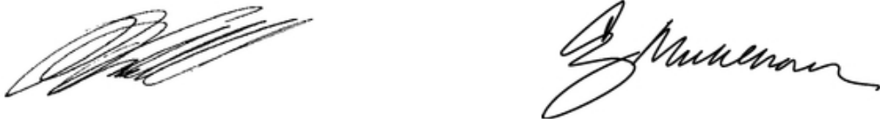

Robert L. Crandall | Craig H. Muhlhauser
Chairman of the Board | President and Chief Executive Officer

Your Vote Is Important

Registered Shareholders

You will have received a form of proxy from the Corporation's transfer agent, Computershare Investor Services Inc., which accompanies your Management Information Circular. Complete, sign, date and mail your form of proxy to Computershare Investor Services Inc. in the envelope provided or follow the instructions provided on the form of proxy to vote by telephone or internet. For instructions regarding how to vote in person at the meeting if you are a registered shareholder, see How Do I Exercise My Vote (and by When)? on page 2 of the Management Information Circular.

Non-Registered Shareholders

You are a non-registered shareholder if your shares are held in the name of a nominee (a securities broker, trustee or other financial institution). You will have received a request for voting instructions from your nominee, which accompanies your Management Information Circular. Alternatively, your nominee may provide you with a form of proxy. Follow the instructions on your voting instruction form to vote by telephone or internet, or complete, sign, date and mail the voting instruction form in the envelope provided. For instructions regarding how to vote in person at the meeting if you are a non-registered shareholder, see How Do I Vote if I am a Non-Registered Shareholder on page 3 of the Circular.

TABLE OF CONTENTS

 | NOTICE OF ANNUAL MEETING OF SHAREHOLDERS OF CELESTICA | i
MANAGEMENT INFORMATION CIRCULAR |  | 1
 | Questions and Answers on Voting and Proxies | 1
 | Principal Holders of Voting Shares | 4
 | Agreement for the Benefit of Holders of Subordinate Voting Shares | 5
 | Information Relating to Our Directors | 5
 | Election of Directors | 5
 | Directors' Compensation | 11
 | Attendance of Directors at Board and Committee Meetings | 17
 | Information About Our Auditor | 18
 | Compensation Discussion and Analysis | 19
 | Compensation Objectives | 19
 | Compensation Elements for the Named Executive Officers | 21
 | Executive Share Ownership | 24
 | Recoupment Provisions | 25
 | 2008 Compensation Decisions | 26
 | Performance Graph | 29
 | Executive Compensation | 31
 | Compensation of Named Executive Officers | 31
 | Securities Authorized for Issuance Under Equity Compensation Plans | 39
 | Indebtedness of Directors And Officers | 42
 | Directors' and Officers' Indemnification and Liability Insurance | 42
 | Management Services Agreement | 42
 | Statement of Corporate Governance Practices | 43
 | Other Matters | 43
 | Requests For Documents | 43
 | Certificate | 44
 | Schedule A | A-1
 | Schedule B | B-1

NOTICE OF ANNUAL MEETING OF SHAREHOLDERS OF CELESTICA

The Annual Meeting of Shareholders (the "Meeting") of CELESTICA INC. (the "Corporation" or "Celestica") will be held at the Glenn Gould Studio, CBC Building, 250 Front Street West, Toronto, Ontario on Thursday, the 23rd day of April, 2009 at 10:00 a.m. (EDT) for the following purposes:

- to receive and consider the financial statements of the Corporation for its financial year ended December 31, 2008, together with the report of the auditor thereon;

- to elect directors for the ensuing year;

- to appoint the auditor for the ensuing year and authorize the directors to fix the auditor's remuneration; and

- to transact such other business as may properly be brought before the Meeting and any adjournment or postponement thereof.

Shareholders are invited to vote at the Meeting by completing, signing, dating and returning the accompanying form of proxy by mail or by following the instructions for voting by telephone or over the internet in the accompanying form of proxy, whether or not they are able to attend personally.

Only shareholders of record at the close of business on March 13, 2009 will be entitled to vote at the Meeting.

DATED at Toronto, Ontario this 11th day of March, 2009.

By Order of the Board of Directors
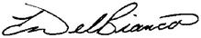

Elizabeth L. DelBianco

Executive Vice President,

Chief Legal and Administrative Officer

and Corporate Secretary

Note: If you are a new shareholder or a non-registered shareholder who did not elect to receive our 2008 Annual Report, you can view that report on our website at www.celestica.com/investor. If you wish to receive a hard copy of the report, please contact us at contactus@celestica.com.

i

CELESTICA INC.
12 Concorde Place, 5th Floor

Toronto, Ontario, Canada M3C 3R8

MANAGEMENT INFORMATION CIRCULAR

In this Management Information Circular (the "Circular"), all information is given as of February 23, 2009 and all dollar amounts are expressed in United States dollars, except where stated otherwise. Unless stated otherwise, all references to "US$" or "$" are to US dollars and all references to "C$" are to Canadian dollars. Unless otherwise indicated, any reference in this Circular to a conversion between US$ and C$ is a conversion at the average of the exchange rates in effect for 2008. During that period, based on the relevant 2008 noon buying rates in New York City for cable transfers in Canadian dollars, as certified for customs purposes by the Federal Reserve Bank of New York, the average exchange rate was US$1.00 = C$1.0660.

QUESTIONS AND ANSWERS ON VOTING AND PROXIES

- WHAT DECISIONS WILL I BE ASKED TO MAKE?

- Shareholders will be voting on the following matters: the election of each individual director to the Board of the Corporation for 2009, the appointment of an auditor for the Corporation for 2009 and authorization of the Board to fix the auditor's remuneration and any other matters as may properly be brought before the Meeting. The Corporation's Board of Directors and management recommend that you vote in favour of each of the proposed nominees for election as directors of the Corporation, and in favour of the appointment of KPMG LLP as auditor of the Corporation to hold office until the next annual meeting of shareholders and the authorization of the Board of Directors of the Corporation to fix the remuneration to be paid to the auditor.

- WHO IS SOLICITING MY PROXY?

- The Corporation's management is soliciting your proxy. All associated costs of solicitation will be borne by the Corporation. The solicitation will be primarily by mail, but proxies may also be solicited personally by regular employees of the Corporation for which no additional compensation will be paid. The Corporation anticipates that copies of this Circular and accompanying proxy will be sent to shareholders on or about March 24, 2009.

- WHO IS ENTITLED TO VOTE?

- The holders of Subordinate Voting Shares or Multiple Voting Shares as at the close of business on March 13, 2009 or their duly appointed representatives are entitled to vote.

As at February 23, 2009, 199,580,858 Subordinate Voting Shares (which carry one vote per share and represent approximately 21% of the voting power of the Corporation's securities) and 29,637,316 Multiple Voting Shares (which carry 25 votes per share and represent approximately 79% of the voting power of the Corporation's securities) were issued and outstanding.

1

- HOW DO I EXERCISE MY VOTE (AND BY WHEN)?

- Non-registered shareholders should refer to How Do I Vote If I Am a Non-Registered Shareholder? on page 3 of this Circular.

If you are a registered shareholder, you may exercise your right to vote by attending and voting your shares in person at the Meeting, by mailing in the attached form of proxy or by voting by telephone or internet.

If you vote your shares in person, your vote will be taken and counted at the Meeting.

If you choose to vote your shares using the form of proxy, your proxy form must be received by the Corporation's registrar and transfer agent, Computershare Investor Services Inc. ("Computershare"), 100 University Avenue, 9th Floor, Toronto, Ontario, Canada M5J 2Y1, not later than 5:00 p.m. (EDT) on Tuesday, April 21, 2009. If the Meeting is adjourned or postponed, Computershare must receive the form of proxy at least 48 hours, excluding Saturdays, Sundays and holidays, before the rescheduled Meeting. Alternatively, the form of proxy may be given to the Chairman of the Meeting at which the form of proxy is to be used.

If you choose to vote your shares by telephone or internet, your vote must be received no later than 5:00 p.m. (EDT) on Tuesday, April 21, 2009.

- WHAT IF I SIGN THE FORM OF PROXY ENCLOSED WITH THIS CIRCULAR?

- Signing the form of proxy gives authority to Mr. Robert L. Crandall or Mr. Craig H. Muhlhauser, or their designees, to vote your shares at the Meeting, unless you give authority to another person to vote your shares by providing that person's name on the form of proxy.

- CAN I APPOINT SOMEONE OTHER THAN THE PERSONS NAMED IN THE FORM OF PROXY ENCLOSED WITH THIS CIRCULAR TO VOTE MY SHARES AT THE MEETING?

- Yes. Write the name of the person of your choice in the blank space provided in the form of proxy. The person whom you choose need not be a shareholder.

Please ensure that the person you have appointed is attending the Meeting and is aware that he or she will be voting your shares. Proxyholders should speak to a representative of Computershare upon arriving at the Meeting.

- HOW WILL MY SHARES BE VOTED AT THE MEETING IF I GIVE MY PROXY?

- On any ballot that may be called for, the shares represented by a properly executed proxy given in favour of the persons designated by management of the Corporation in the enclosed form of proxy will be voted or withheld from voting in accordance with the instructions given on the ballot, and if you specify a choice with respect to any matter to be acted upon, the shares will be voted accordingly.

The persons named in the form of proxy must vote or withhold from voting your shares in accordance with your instructions on the form of proxy. In the absence of such directions and unless you specify a person other than Mr. Crandall or Mr. Muhlhauser to vote your shares, your shares will be voted in favour of the election to the Corporation's Board of the nominees proposed by management and in favour of the appointment of KPMG LLP as the Corporation's auditor for 2009 and the authorization of the Board to fix the auditor's remuneration.

- IF I CHANGE MY MIND, CAN I TAKE BACK MY PROXY ONCE I HAVE GIVEN IT?

- Yes, you may revoke any proxy that you have given at any time prior to its use at the Meeting for which it was given or any adjournment or postponement thereof. In addition to revocation in any other manner permitted by law, you may revoke the proxy by preparing a written statement, signed by you or your attorney, as authorized, or if the proxy is given on behalf of a corporation, by a duly authorized officer or attorney of such corporation, and deposited with the Chairman of the Meeting on the day of the Meeting, or any adjournment or postponement thereof, prior to the proxy being voted, or by transmitting, by telephonic or electronic means, a revocation signed by electronic signature by you or by your attorney, who is authorized in writing, to, the registered office of the Corporation at any time up to and including the last business day preceding the day of the

2

Meeting, or any adjournment or postponement thereof, at which the proxy is to be used.

Note that your participation in person in a vote by ballot at the Meeting will automatically revoke any proxy previously given by you regarding business considered by that vote.

- WHAT IF AMENDMENTS ARE MADE TO THE SCHEDULED MATTERS OR IF OTHER MATTERS ARE BROUGHT BEFORE THE MEETING?

- The accompanying form of proxy confers discretionary authority upon the proxy nominees in respect of any amendments or variations to matters identified in the Notice of Meeting or other matters that may properly come before the Meeting or any adjournment(s) or postponement(s) thereof.

As of the date of this Circular, the Corporation's management was not aware of any such amendments, variations or other matters to come before the Meeting. However, if any amendments, variations or other matters which are not now known to management should properly come before the Meeting or any adjournment(s) or postponement(s) thereof, the shares represented by proxies in favour of the management nominees will be voted on such matters in accordance with the best judgment of the proxy nominees.

- HOW WILL THE VOTES BE COUNTED?

- Each question brought before the Meeting is determined by a majority of the votes cast on the question by both Subordinate Voting Shareholders and Multiple Voting Shareholders voting as a single class.

- HOW DO I VOTE IF I AM A NON-REGISTERED SHAREHOLDER?

- The form of proxy provided with this Circular will indicate whether or not you are a registered shareholder. Non-registered shareholders hold their shares through intermediaries, such as banks, trust companies, securities dealers or brokers. If you are a non-registered shareholder, the intermediary holding your shares should provide a voting instruction form which you must complete, sign and return in accordance with the instructions set forth therein. This form will constitute voting instructions which the intermediary must follow.

Alternatively, the intermediary may provide you with a signed form of proxy. In this case, you do not need to sign the form of proxy, but should complete it and forward it directly to Computershare.

Should you, as a non-registered shareholder, wish to attend the Meeting and vote your shares in person, or have another person attend and vote your shares on your behalf, you should fill in your own name, or the name of your appointee, in the space provided on the form of proxy. An intermediary's voting instruction form will likely provide corresponding instructions to cast your vote in person. In any case, you should carefully follow the instructions provided by the intermediary and contact the intermediary promptly if you require assistance.

If you vote by mail and would subsequently like to change your vote (whether by revoking a voting instruction or by revoking a proxy), you should contact the intermediary to discuss whether this is possible and, if so, what procedures you should follow.

- HOW CAN I CONTACT THE INDEPENDENT DIRECTORS AND NON-EXECUTIVE CHAIRMAN?

- You may contact the independent directors, including the independent Chairman of the Corporation, with the assistance of Celestica Investor Relations. Shareholders or other interested persons can send a letter, e-mail or fax c/o Celestica Investor Relations at the following coordinates:

Celestica Investor Relations

12 Concorde Place, 5th Floor Toronto Canada M3C 3R8 Phone: 416-448-2211

Fax: 416-448-2280

E-mail: clsir@celestica.com

- WHOM SHOULD I CONTACT IF I HAVE QUESTIONS CONCERNING THE CIRCULAR OR FORM OF PROXY?

- If you have questions concerning the information contained in this Circular or require assistance in completing the proxy form you may contact the transfer agent.

- HOW CAN I CONTACT THE TRANSFER AGENT?

- You may contact the transfer agent by mail:

Computershare Investor Services Inc. 100 University Avenue, 9th Floor Toronto, Ontario M5J 2Y1

or by telephone:

within Canada and the United States 1-800-564-6253
all other countries 514-982-7555

3

PRINCIPAL HOLDERS OF VOTING SHARES

As of February 23, 2009, the only persons or corporations who, to the knowledge of the Corporation, its directors or executive officers, beneficially own, or control or direct, directly or indirectly, voting securities carrying 10% or more of the voting rights attached to any class of the voting securities of the Corporation are as follows:

Table 1: Principal Holders of Voting Shares

Name |  |  |  | Percentage of
 |  | Number of | Percentage of | All Equity | Percentage of
 |  | Shares | Class | Shares | Voting Power
Onex Corporation⁽¹⁾ |  | 29,637,316 | 100% | 12.9% | 78.8%
Toronto, Ontario |  | Multiple
 |  | Voting Shares
 |  | 1,996,231 | 1.0% | * | *
 |  | Subordinate
 |  | Voting Shares
Gerald W. Schwartz⁽²⁾ |  | 29,637,316 | 100% | 12.9% | 78.8%
Toronto, Ontario |  | Multiple
 |  | Voting Shares
 |  | 2,184,975 | 1.1% | 1.0% | *
 |  | Subordinate
 |  | Voting Shares
Mackenzie Financial Corporation⁽³⁾ |  | 31,678,931 | 15.9% | 13.8% | 3.4%
Toronto, Ontario |  | Subordinate
 |  | Voting Shares

- Less than 1%.

- The number of shares beneficially owned, or controlled or directed, directly or indirectly, by Onex Corporation ("Onex") includes 11,635,958 Multiple Voting Shares held by a wholly-owned subsidiary of Onex, 1,382,403 Subordinate Voting Shares held in trust for Celestica Employee Nominee Corporation as agent for and on behalf of employees of Celestica pursuant to Celestica's employee share purchase plan and 160,492 Subordinate Voting Shares directly or indirectly held by certain officers of Onex, which Onex or such other person has the right to vote.

- The number of shares beneficially owned, or controlled or directed, directly or indirectly, by Mr. Schwartz includes 188,744 Subordinate Voting Shares owned by a company controlled by Mr. Schwartz and all of the 29,637,316 Multiple Voting Shares and 1,996,231 Subordinate Voting Shares beneficially owned, or controlled or directed, directly or indirectly, by Onex, of which 1,077,500 Subordinate Voting Shares are subject to options granted to Mr. Schwartz pursuant to certain management investment plans of Onex and 1,382,403 Subordinate Voting Shares held in trust for Celestica Employee Nominee Corporation as agent for and on behalf of employees of Celestica pursuant to Celestica's employee share purchase plan. Mr. Schwartz is a director of the Corporation and the Chairman of the Board, President and Chief Executive Officer of Onex, and owns Multiple Voting Shares of Onex carrying the right to elect a majority of the Onex board of directors. Accordingly, under applicable securities laws, Mr. Schwartz is deemed to be the beneficial owner of the Celestica shares owned by Onex; Mr. Schwartz has advised the Corporation, however, that he disclaims any rights of such beneficial ownership of the shares held by Onex and Celestica Employee Nominee Corporation.

- This information reflects share ownership as of December 31, 2008 and is taken from Schedule 13G filed by Mackenzie Financial Corporation with the SEC on January 20, 2009.

4

Agreement for the Benefit of Holders of Subordinate Voting Shares

Onex Corporation ("Onex"), which, directly or indirectly, owns all of the outstanding Multiple Voting Shares, has entered into an agreement with the Corporation and with Computershare Trust Company of Canada, as trustee for the benefit of the holders of the Subordinate Voting Shares, to ensure that the holders of the Subordinate Voting Shares will not be deprived of any rights under applicable take-over bid legislation to which they would be entitled in the event of a take-over bid as if the Multiple Voting Shares and Subordinate Voting Shares were of a single class of shares. Subject to certain permitted forms of sale, Onex has agreed that it, and any of its affiliates which may hold Multiple Voting Shares from time to time, will not sell any Multiple Voting Shares, directly or indirectly, pursuant to a take-over bid (as that term is defined under applicable securities legislation and the agreement) under circumstances in which any applicable securities legislation would have required the same offer or a follow-up offer to be made to holders of Subordinate Voting Shares if the sale had been a sale of Subordinate Voting Shares rather than Multiple Voting Shares, but otherwise on the same terms.

The Articles of the Corporation provide "coat-tail" protection to the holders of the Subordinate Voting Shares by providing that the Multiple Voting Shares will be converted automatically into Subordinate Voting Shares upon any transfer thereof, except (a) a transfer to Onex or any affiliate of Onex, or (b) a transfer of 100% of the outstanding Multiple Voting Shares to a purchaser who also has offered to purchase all of the outstanding Subordinate Voting Shares for a per share consideration identical to, and otherwise on the same terms as, that offered for the Multiple Voting Shares and the Multiple Voting Shares held by such purchaser thereafter shall be subject to the provisions relating to conversion as if all references to Onex were references to such purchaser. In addition, if (a) any holder of any Multiple Voting Shares ceases to be an affiliate of Onex, or (b) Onex and its affiliates cease to have the right, in all cases, to exercise the votes attached to, or to direct the voting of, any of the Multiple Voting Shares held by Onex and its affiliates, such Multiple Voting Shares shall convert automatically into Subordinate Voting Shares on a one-for-one basis. See footnote 3 to Item 7A on page 91 in the Corporation's Annual Report on Form 20-F.

INFORMATION RELATING TO OUR DIRECTORS

Election of Directors

The eight individuals listed below are being recommended for election as directors of the Corporation. If elected, they will hold office until the close of the next annual meeting of shareholders or until their successors are elected or appointed, unless such office is earlier vacated in accordance with the Corporation's By-laws. All of the proposed nominees, with the exception of Ms. Laurette Koellner, are now directors of the Corporation. The Articles of the Corporation provide for a minimum of three and a maximum of 20 directors. The Board of Directors of the Corporation (the "Board of Directors" or the "Board") has the authority to set the number of directors of the Corporation to be elected at the Meeting and has set that number at eight.

Unless authority to do so is withheld, proxies given pursuant to this solicitation by the management of the Corporation will be voted in favour of each of the proposed nominees for election as directors. Management of the Corporation does not contemplate that any of the nominees will be unable, or for any reason unwilling, to serve as a director, but if that should occur for any reason prior to their election, the proxy nominees may, in their discretion, nominate and vote for another nominee.

There are no contracts, arrangements or understandings between any director or executive officer or any other person pursuant to which any of the nominees have been nominated.

The Board adopted a policy that requires in an uncontested election of directors that: shareholders will be able to vote in favour of, or to withhold from voting, separately for each director nominee; if, with respect to any particular nominee, other than the controlling shareholder or a representative of the controlling shareholder, the number of shares withheld from voting by shareholders other than the controlling shareholders and its associates exceeds

5

the number of shares that they vote in favour of the nominee, then the Board will determine, and in so doing will give due weight to the rights of the controlling shareholder, whether to require the nominee to resign from the Board; if the Board determines that such a nominee should resign, the nominee will resign and the Board will accept the resignation; it is expected that such a determination by the Board will be made, and announced, within 90 days after the applicable shareholders' meeting; and, subject to any corporate law restrictions, the Board may leave any resultant vacancy unfilled until the next annual shareholders' meeting or it may fill the vacancy through the appointment of a new director whom the Board considers to merit the confidence of the shareholders or it may call a special meeting of shareholders at which there will be presented a management slate to fill the vacant position or positions.

The following tables set out certain information with respect to the nominees, including their municipalities of residence; their ages; the year from which each has

continually served as a director of the Corporation; all positions and offices held by them with the Corporation or any of its significant affiliates; their present

principal occupations, businesses and employments; in the case of Mr. Ryan and Ms. Koellner who did not stand for election as directors at the Corporation's

previous annual meeting, their principal occupations, businesses or employments during the past five years; and other corporations of which they are directors.

For a description of the number of shares, options, deferred share units ("DSUs") and restricted share units ("RSUs") beneficially owned, directly or indirectly, or

over which control or direction is exercised by the Corporation's directors, and a description of the DSUs and RSUs, see Directors' Compensation on page 11

and Compensation Discussion and Analysis on page 19, respectively of this Circular, and, in the case of securities of the Corporation owned, directly or indirectly,

by Mr. Schwartz and his associates and affiliates, also see Principal Holders of Voting Shares on page 4.

6

Nominees for Election as Director

Name of Nominee | Age | Director Since
Robert L. Crandall | 73 | 1998
Palm City, Florida
United States
 | Mr. Crandall has been a director of the Corporation since 1998 and Chairman of the Board of
 | Directors of the Corporation since January 2004. He is the retired Chairman of the Board and
 | Chief Executive Officer of AMR Corporation/American Airlines Inc. Mr. Crandall currently
 | serves on the board of Anixter International Inc., which is a public corporation. He is also
 | Chairman and CEO of Pogo, Inc. and a director of Air Cell, Inc., both of which are privately
 | held companies. Mr. Crandall is a member of the Federal Aviation Administration
 | Management Advisory Committee. He holds a Bachelor of Science degree from the
 | University of Rhode Island and a Master of Business Administration degree from the
 | Wharton School of the University of Pennsylvania.
 | Mr. Crandall sits on the Audit, Compensation, Nominating and Corporate Governance and
 | Executive Committees.
William A. Etherington | 67 | 2001
Toronto, Ontario,
Canada


Mr. Etherington has been a director of the Corporation since 2001. He was a director and the Non-Executive Chairman of the Board of the Canadian Imperial Bank of Commerce until February 26, 2009 and is a director of MDS Inc. and Onex Corporation, each of which is a public corporation. Mr. Etherington is also a director of SS&C Technologies Inc., a private firm. He is the former Senior Vice President and Group Executive, Sales and Distribution, IBM Corporation, and Chairman, President and Chief Executive Officer of IBM World Trade Corporation. He retired from IBM in 2001 with over 37 years of service. Mr. Etherington is a member of the President's Council, The University of Western Ontario and director of

St. Michael's Hospital. He holds a Bachelor of Science degree in Electrical Engineering and a Doctor of Laws (Hon.) from the University of Western Ontario.

Mr. Etherington sits on the Audit, Compensation, Nominating and Corporate Governance and Executive Committees.

7

Laurette Koellner 54 N/A

Merritt Island, Florida

United States

Laurette Koellner is the retired President of Boeing International, a division of The Boeing Company. In this role, Ms. Koellner oversaw the company's international affairs and had leadership responsibilities for 20 Boeing in-country operations throughout the world. Previously, she was President of Connexion by Boeing from December 2004 to 2006. Prior to that, Ms. Koellner was a member of the Office of the Chairman and served as the Executive Vice President, Internal Services and Chief Human Resources and Administrative Officer for The Boeing Company from 2002 to 2004. Other roles at Boeing included President of Shared Services, as well as Corporate Controller. Ms. Koellner joined Boeing as a result of the company's merger with McDonnell Douglas in 1997. She spent 19 years at McDonnell Douglas, where she held a number of management roles of increasing responsibility in the areas of contracts, business planning, human resources and auditing. Her last role at McDonnell Douglas was Vice President of Internal Audit.


Ms. Koellner currently serves on the board of Sara Lee Corporation, which is a public corporation, as a member of the governance and nominating committee, as well as chair of the audit committee. She is a member of the University of Central Florida Dean's Executive Council, and a member of the Council on Foreign Relations. She holds a Bachelor of Science degree in Business Management from the University of Central Florida and a Masters of Business Administration from Stetson University in Deland, Florida. She holds a Certified Professional Contracts Manager designation from the National Contracts Management Association.

Richard S. Love | 71 | 1998
San Diego, California,

United States

Mr. Love has been a director of the Corporation since 1998. He is a former Vice President of Hewlett-Packard and a former General Manager of the Computer Order Fulfillment and Manufacturing Group for Hewlett-Packard's Computer Systems Organization. From 1962 until 1997, he held positions of increasing responsibility with Hewlett-Packard, becoming Vice President in 1992. He is a former director of HMT Technology Corporation (electronics manufacturing) and the Information Technology Industry Council. Mr. Love holds a Bachelor of Science degree in Business Administration and Technology from Oregon State University, and a Master of Business Administration degree from Fairleigh Dickinson University.


Mr. Love sits on the Nominating and Corporate Governance Committee.

8

Craig H. Muhlhauser | 60 | 2007
Princeton, New Jersey,
United States
 | Mr. Muhlhauser is President and Chief Executive Officer, and, since 2007, is also a director,
 | of the Corporation. Prior to his current position, he was President and Executive Vice
 | President of Worldwide Sales and Business Development. Before joining the Corporation in
 | May 2005, Mr. Muhlhauser was the President and Chief Executive Officer of Exide
 | Technologies. He was serving as President of Exide Technologies when that entity filed for
 | bankruptcy in 2002, was named Chief Executive Officer of Exide Technologies shortly
 | thereafter and successfully led the company out of bankruptcy protection in 2004. Prior to
 | that, he held the role of Vice President, Ford Motor Company and President, Visteon
 | Automotive Systems. Throughout his career, he has worked in a range of industries spanning
 | the consumer, industrial, communications, utility, automotive and aerospace and defense
 | sectors. He is a director of Intermet Corporation, a privately held company, which filed for
 | bankruptcy in the US in August 2008 and is currently operating under bankruptcy protection.
 | He holds a Master of Science degree in Mechanical Engineering and a Bachelor of Science
 | degree in Aerospace Engineering from the University of Cincinnati.
 | Mr. Muhlhauser does not sit on any committees of the Board of Directors of the Corporation.
Eamon J. Ryan | 63 | 2008
Toronto, Ontario,
Canada


Eamon J. Ryan is the former Vice President and General Manager, Europe, Middle East and Africa for Lexmark International Inc. Prior to that, he was the Vice President and General Manager, Printing Services and Solutions Manager, Europe, Middle East and Africa.

Mr. Ryan joined Lexmark in 1991 as the President of Lexmark Canada. Before Lexmark, he spent 22 years at IBM Canada, where he held a number of sales and marketing roles in their Office Products and Large Systems divisions. Mr. Ryan's last role at IBM Canada was Director of Operations for their Public Sector — a role he held from 1986 to 1990. He holds a Bachelor of Arts degree from the University of Western Ontario.

Mr. Ryan does not sit on any committees of the Board of Directors of the Corporation.

9

Gerald W. Schwartz | 67 | 1998
Toronto, Ontario,
Canada | Mr. Schwartz has been a director of the Corporation since 1998. He is the Chairman of the
 | Board, President and Chief Executive Officer of Onex Corporation. Prior to founding Onex in
 | 1983, Mr. Schwartz was a co-founder and President (in 1977) of what is now CanWest Global
 | Communications Corp. Mr. Schwartz was inducted into the Canadian Business Hall of Fame
 | in 2004 and was appointed as an Officer of the Order of Canada in 2006. He is also an
 | honorary director of the Bank of Nova Scotia and is a director of Indigo Books & Music Inc.,
 | which is a public corporation. Mr. Schwartz is Vice Chairman of Mount Sinai Hospital and is
 | a director, governor or trustee of a number of other organizations, including Junior
 | Achievement of Toronto, the Canadian Council of Christians and Jews, and The Simon
 | Wiesenthal Center. He holds a Bachelor of Commerce degree and a Bachelor of Laws degree
 | from the University of Manitoba, a Master of Business Administration degree from the
 | Harvard University Graduate School of Business Administration, a Doctor of Laws (Hon.)
 | from St. Francis Xavier University and a Doctor of Philosophy (Hon.) from Tel Aviv
 | University.
 | Mr. Schwartz does not sit on any committees of the Board of Directors of the Corporation.
Don Tapscott | 61 | 1998
Toronto, Ontario,
Canada


Don Tapscott is Chairman of the thinktank, nGenera Insight and an adjunct Professor of Management at the University of Toronto's Joseph L. Rotman School of Management.

Mr. Tapscott is also an internationally respected authority, consultant and speaker on business strategy and organizational transformation and the author of thirteen widely-read books on the application of technology in business. He is also a founding member of the Business and Economic Roundtable on Addiction and Mental Health, and a fellow of the World Economic Forum. Mr. Tapscott has been a director of the Corporation since 1998. He holds a Bachelor of Science degree in Psychology and Statistics, and a Master of Education degree, specializing in Research Methodology, as well as Doctor of Laws (Hon.) degrees from the University of Alberta and Trent University.

Mr. Tapscott sits on the Audit, Compensation and Nominating and Corporate Governance Committees.

10

Directors' Compensation

Interlocking Directorships

None of the directors of the Corporation serve together as directors of other corporations other than Mr. Schwartz and Mr. Etherington who serve together on the board of directors of Onex.

Directors' Compensation

Director compensation is set by the Board on the recommendation of the Compensation Committee and in accordance with director compensation guidelines

established by the Nominating and Corporate Governance Committee (the "Governance Committee"). Under these guidelines, the Board seeks to maintain

director compensation at a level that is competitive with director compensation at comparable companies. The Compensation Committee engaged Towers

Perrin Inc. ("Towers Perrin") to provide benchmarking information in this regard. (See pages 19 and 20 for a discussion regarding the role of Towers Perrin.) The

guidelines also contemplate that at least half of each director's annual retainer and meeting fees be paid in deferred share units ("DSUs"). Each DSU represents

the right to receive one Subordinate Voting Share or an equivalent value in cash of the Corporation when the director ceases to be a director.

2008 Fees

Table 2 sets out the annual retainers and meeting fees paid in 2008 to the Corporation's directors (other than Messrs. Schwartz and Muhlhauser who, as officers of Onex and the Corporation, respectively, did not receive such compensation).

 | Table 2: Retainers and Meeting Fees for 2008
Annual Board Retainer |  | $65,000
Annual Retainer for non-executive Chairman⁽¹⁾ |  | $130,000
Annual Retainer for Audit Committee Chair |  | $20,000
Annual Retainer for Compensation Committee Chair |  | $10,000
Annual Retainer for Executive Committee Chair |  | $10,000
Board and Committee Per Day Meeting Fee⁽²⁾ |  | $2,500
Travel Fee⁽³⁾ |  | $2,500
Annual DSU Grant (for directors other than the Chairman) |  | $65,000
Annual DSU Grant — Chairman |  | $130,000

- The non-executive Chairman of the Board also serves as chair of the Governance Committee, for which no additional fee is paid.

- Attendance fees are paid per day of meetings, regardless of whether a director attends more than one meeting in a single day, except that a separate attendance fee is paid for each Executive Committee meeting, even if it occurs on the same day as other meetings.

- The travel fee is available only to directors who travel outside of their home state or province to attend a Board or Committee meeting.

11

DSUs

Directors receive half of their annual retainer and meeting fees (or all such fees, if they so elect) in DSUs. The number of DSUs granted in lieu of cash meeting fees is calculated by dividing the cash fee that would otherwise be payable by the closing price of Subordinate Voting Shares on the New York Stock Exchange (the "NYSE") on the last business day of the quarter in which the applicable meeting occurred. In the case of annual retainer fees, the number of DSUs granted is calculated by dividing the cash amount that would otherwise be payable quarterly by the closing price of Subordinate Voting Shares on the NYSE on the last business day of the quarter.

Directors also receive annual grants of DSUs. In 2008, each director received $65,000 worth of DSUs, except for the Chairman, who received $130,000. The number of DSUs granted is calculated by dividing the cash amount that would otherwise be payable quarterly by the closing price of Subordinate Voting Shares on the NYSE on the last business day of the quarter.

Eligible directors also receive an initial grant of DSUs when they are appointed to the Board. For individuals who become eligible directors after December 31, 2008, the initial grant is equal to the amount of the annual board retainer multiplied by 150% and divided by the closing price of Subordinate Voting Shares on the NYSE on the last business day of the fiscal quarter immediately preceding the date when the individual becomes an eligible director. The DSUs comprising the initial grant vest upon the retirement of the eligible director. However, if an eligible director retires within a year of becoming an eligible director, all of the DSUs comprising the initial grant are forfeited and cancelled. If an eligible director retires less than two years but more than one year after becoming an eligible director, then two-thirds of the DSUs comprising the initial grant are forfeited and cancelled. If an eligible director retires within three years but more than two years after becoming an eligible director, then one-third of the DSUs comprising the initial grant are forfeited and cancelled. Forfeiture does not apply if a director ceases to be a director due to a change of control.

The compensation paid in 2008 by the Corporation to its directors is set out in Table 3. None of the directors received any fee or payment from the Corporation except as set out below. Mr. Schwartz is an officer of Onex and did not receive any compensation in his capacity as a director of the Corporation in 2008. Mr. Muhlhauser, as President and Chief Executive Officer of the Corporation, also did not receive any director's fees from the Corporation in 2008.

Table 3: Director Fees Earned in 2008

 |  |  |  |  |  |  |  |  |  |  | Initial
 |  |  |  |  |  |  |  | Total Annual | Portion of Fees | Annual | DSU
 |  |  |  |  |  | Committee | Total | Retainer and | Portion of Fees | Annual | Grant
 |  | Board |  | Chairman |  | Chair | Meeting | Meeting Fees | Taken in Cash or | DSU Grant (#) | (#) and
Name |  | Annual |  | Annual |  | Annual | Attendance | Payable | Applied to DSUs and | and Value of | Value of | Total
Name |  | Retainer |  | Retainer |  | Retainer | Fees | ((a)+(b)+(c)+(d)) | Value of DSUs⁽¹⁾ | DSUs⁽¹⁾ | DSUs | ((e)+(g)+
 |  | (a) |  | (b) |  | (c) | (d) | (e) | (f) | (g) | (h) | (h))
Robert L. Crandall |  | — | $ | 130,000 | $ | 30,000 | $70,000 | $230,000 | 100% | 20,788/$130,000 | — | $360,000
 |  |  |  |  |  |  |  |  | DSUs/$230,000
William A. Etherington | $ | 65,000 |  | — | $ | 10,000 | $50,000 | $125,000 | 100% | 10,394/$65,000 | — | $190,000
 |  |  |  |  |  |  |  |  | DSUs/$125,000
Richard S. Love | $ | 65,000 |  | — |  | — | $55,000 | $120,000 | 50% Cash & 50% | 10,394/$65,000 | — | $185,000
 |  |  |  |  |  |  |  |  | DSUs/$60,000
Anthony R. Melman⁽²⁾ | $ | 20,357 |  | — |  | — | $7,500 | $27,857 | 100% | 3,029/$20,357 | — | $48,214
 |  |  |  |  |  |  |  |  | DSUs/$27,857
Eamon J. Ryan⁽³⁾ | $ | 16,250 |  | — |  | — | $7,500 | $23,750 | 100% | 3,525/$16,250 | 27,950/ | $220,000
 |  |  |  |  |  |  |  |  | DSUs/$23,750 | $ | 180,000
Charles W. Szuluk⁽⁴⁾ | $ | 32,500 |  | — |  | — | $12,500 | $45,000 | 100% DSUs/$45,000 | 4,346/$32,500 | — | $77,500
Don Tapscott | $ | 65,000 |  | — |  | — | $25,000 | $90,000 | 100% DSUs/$90,000 | 10,394/$65,000 | — | $155,000

12

- The annual retainer, meeting fees and annual grant for 2008 were paid quarterly and the number of DSUs granted in respect of the amounts paid quarterly for each such item was determined using the closing prices of Subordinate Voting Shares on the NYSE on the last business day of each quarter, which were $6.72 on March 31, 2008, $8.43 on June 30, 2008, $6.44 on September 30, 2008 and $4.61 on December 31, 2008.

- Dr. Melman did not stand for re-election to the Board of Directors at the Corporation's previous annual meeting and accordingly he ceased being a director on April 24, 2008.

- Mr. Ryan was appointed a director on October 24, 2008. He received an initial grant of DSUs valued at $180,000.

- Mr. Szuluk retired from the Board of Directors on June 30, 2008.

The total fees earned by the Board in 2008 were $661,607. In addition, a total annual grant of DSUs worth $394,107 and an initial grant of DSUs worth $180,000 were issued.

Outstanding Option-Based and Share-Based Awards

In 2005, the Corporation amended its Long Term Incentive Plan ("LTIP") to prohibit the granting of options to acquire Subordinate Voting Shares to directors. Table 4 sets out information relating to option grants to directors which were made between 1998 and 2004 and which remain outstanding. All option grants were made with exercise prices set at the closing market price on the business day prior to the date of grant. Exercise prices range from $10.62 to C$72.60. Options vest over three or four years and expire after ten years. The final grant of options occurred on May 10, 2004; those options will expire on May 10, 2014.

Mr. Schwartz, as an employee of Onex during that period, was not granted options. Mr. Ryan became a director on October 24, 2008 and was not granted any options under the LTIP.

DSUs that were granted prior to January 1, 2007 will be paid out in the form of Subordinate Voting Shares issued from treasury. DSUs granted after January 1, 2007 will be paid out in the form of Subordinate Voting Shares purchased in the open market or an equivalent value in cash. The date used in valuing the DSUs shall be a date within 90 days of the date on which the individual in question ceases to be a director. The DSUs shall be redeemed and payable on or prior to the 90th day following the date on which the individual ceases to be a director. The total number of DSUs outstanding is included in Table 4.

The following table sets out for each director information concerning all option-based and share-based awards outstanding as of December 31, 2008 (this includes awards granted before the most recently completed financial year).

13

Table 4: Outstanding Option-Based and Share-Based Awards

 |  |  | Option-Based Awards⁽¹⁾ |  |  |  | Share-Based Awards⁽²⁾
 |  | Number of |  |  |  |  |  | Market
 |  | Securities |  |  | Value of |  |  | Payout Value
 |  | Underlying | Option |  | Unexercised |  | Number of | of
Name |  | Unexercised | Exercise | Option | In-the-Money |  | Outstanding | Outstanding
 |  | Options | Price | Expiration | Options |  | Units | Units
 |  | (#) | ($) | Date | ($) | (#) |  | ($)
Robert L. Crandall
Jul. 7, 1999 |  | 20,000 | $23.41 | Jul. 7, 2009 | — |  | — | —
Jul. 7, 2000 |  | 20,000 | $48.69 | Jul. 7, 2010
Jul. 7, 2001 |  | 20,000 | $44.23 | Jul. 7, 2011 | — |  | — | —
Apr. 18, 2003 |  | 10,000 | $10.62 | Apr. 18, 2013
May 10, 2004 |  | 10,000 | $18.25 | May 10, 2014 | — |  | — | —
— |  | — | — | — | — |  | — | —
 |  |  |  |  | — |  | — | —
 |  |  |  |  | — | 248,621 |  | $1,146,143
William A. Etherington
Oct. 22, 2001 |  | 20,000 | $35.95 | Oct. 22, 2011 | — |  | — | —
Apr. 21, 2002 |  | 5,000 | $32.40 | Apr. 21, 2012
Apr. 18, 2003 |  | 5,000 | $10.62 | Apr. 18, 2013 | — |  | — | —
May 10, 2004 |  | 5,000 | $18.25 | May 10, 2014
— |  | — | — | — | — |  | — | —
 |  |  |  |  | — |  | — | —
 |  |  |  |  | — | 97,111 |  | $447,682
Richard S. Love
Jul. 7, 1999 |  | 10,000 | $23.41 | Jul. 7, 2009 | — |  | — | —
Jul. 7, 2000 |  | 10,000 | $48.69 | Jul. 7, 2010
Jul. 7, 2001 |  | 10,000 | $44.23 | Jul. 7, 2011 | — |  | — | —
Apr. 18, 2003 |  | 2,500 | $10.62 | Apr. 18, 2013
May 10, 2004 |  | 2,500 | $18.25 | May 10, 2014 | — |  | — | —
— |  | — | — | — | — |  | — | —
 |  |  |  |  | — |  | — | —
 |  |  |  |  | — | 52,114 |  | $240,246
Eamon J. Ryan |  | — | — | — | — | 36,627 |  | $168,850
Don Tapscott
Jul. 7, 1999 |  | 20,000 | C$34.50 | Jul. 7, 2009 | — |  | — | —
Jul. 7, 2000 |  | 20,000 | C$72.60 | Jul. 7, 2010
Jul. 7, 2001 |  | 20,000 | C$66.78 | Jul. 7, 2011 | — |  | — | —
Apr. 18, 2003 |  | 5,000 | $10.62 | Apr. 18, 2013
May 10, 2004 |  | 5,000 | $18.25 | May 10, 2014 | — |  | — | —
— |  | — | — | — | — |  | — | —
 |  |  |  |  | — |  | — | —
 |  |  |  |  | — | 98,632 |  | $454,694

- All options granted under the option-based awards have vested.

- Represents all outstanding share units. The market payout value was determined using a share price of $4.61, which was the closing price of Subordinate Voting Shares on the NYSE on December 31, 2008.

14

Directors' Equity Interest

The following table sets out each director's direct or indirect beneficial ownership of, or control or direction over, equity in the Corporation, and any changes therein since February 25, 2008.

Table 5: Equity Interest Other than Options and

Outstanding Share-Based Awards⁽¹⁾

Name |  | _{SVS}(2)
 | Date | # | Market Value*
Robert L. Crandall | Feb. 25, 2008 | 20,000 | $219,100
 | Feb. 23, 2009 | 70,000
 | Change | 50,000
William A. Etherington | Feb. 25, 2008 | 10,000 | $31,300
 | Feb. 23, 2009 | 10,000
 | Change | —
Richard S. Love | Feb. 25, 2008 | 5,000 | $15,650
 | Feb. 23, 2009 | 5,000
 | Change | —
Eamon J. Ryan | Feb. 25, 2008 | —
 | Feb. 23, 2009 |  | —
 | Change | —
 |  | —
Gerald W. Schwartz⁽³⁾ | Feb. 25, 2008 | 2,236,713 | $6,838,972
 | Feb. 23, 2009 | 2,184,975
 | Change | - -51,738
Don Tapscott | Feb. 25, 2008 | 5,700 | $17,841
 | Feb. 23, 2009 | 5,700
 | Change | —

- Based on the NYSE closing share price of $3.13 on February 23, 2009.

- Information as to securities beneficially owned, or controlled or directed, directly or indirectly, is not within the Corporation's knowledge and therefore has been provided by each nominee.

- Certain Subordinate Voting Shares subject to options granted pursuant to management investment plans of Onex are included as owned beneficially by named individuals although the exercise of these options is subject to Onex meeting certain financial targets. More than one person may be deemed to have beneficial ownership of the same securities.

- As described in note 2 to Table 1, Mr. Schwartz is deemed to be the beneficial owner of the 29,637,316 Multiple Voting Shares owned by Onex, which have a market value of $92,764,799 as of February 23, 2009 and which result, together with the market values of his Subordinate Voting Shares, in a total market value of $99,603,771 as of February 23, 2009 for his aggregate equity interest in the Corporation.

Shareholding Requirements

The Corporation has minimum shareholding requirements for independent directors (the "Guideline"). The Guideline provides that an independent director who has been on the Board:

- for five years or more must hold securities of the Corporation having a market value of at least five times that director's then applicable annual retainer and, after such level of ownership has been obtained, shall continue to invest a significant portion of the annual retainer in securities of the Corporation;

- for two years or more (but less than five years) must hold securities of the Corporation having a market value of at least three times that director's then applicable annual retainer;

15

- for one year or more (but less than two years) must hold securities of the Corporation having a market value of at least one times that director's then applicable annual retainer; and

- for less than a year are encouraged, but not required, to hold securities of the Corporation.

Although directors will not be deemed to have breached the Guideline by reason of a decrease in the market value of the Corporation's securities, the directors may be required to purchase further securities within a reasonable period of time to comply with the Guideline. The Guideline came into effect on April 22, 2004 and each director's holdings of securities, which for the purposes of the Guideline include all Subordinate Voting Shares, DSUs and RSUs, are reviewed annually each year on December 31. Given the recent downturn in the performance of financial markets as a result of uncertainty in the global economy, the Corporation has extended the Guideline's targeted compliance date by one year. As of December 31, 2008, all of the directors of the Corporation were, or were on track to be, in compliance with the Guideline as set out in the following table.

Table 6: Shareholding Requirements

 |  |  |  |  | Shareholding Requirements
Director |  |  |  | Target Value | Date by which Target to | Value as of | On Track as of
 |  |  |  | (5x annual retainer) | be Met | December 31, 2008⁽³⁾ | December 31, 2008⁽⁴⁾
Robert L. Crandall |  | $ |  | 800,000 | Apr. 22, 2010 | $1,468,843 | Yes
William A. Etherington |  | $ |  | 375,000 | Apr. 22, 2010 | $493,782 | Yes
Richard S. Love |  | $ |  | 325,000 | Apr. 22, 2010 | $263,296 | Yes
Eamon J. Ryan⁽¹⁾ |  |  |  | — | — | — | —
Gerald W. Schwartz⁽²⁾ |  |  |  | — | — | — | —
Don Tapscott |  | $ |  | 325,000 | Apr. 22, 2010 | $480,971 | Yes

- As Mr. Ryan has been on the Board for less than one year, he is not required to hold securities of the Corporation pursuant to the Guideline.

- As Mr. Schwartz is not an independent director, he is not subject to the minimum shareholding requirements of the Guideline.

- The value of the aggregate number of Subordinate Voting Shares, DSUs and RSUs held by each director is determined using a share price of $4.61, which was the closing price of Subordinate Voting Shares on the NYSE on December 31, 2008.

- For the purposes of determining compliance with the Guideline, directors' fees to be earned in 2009 are included. It should be noted that the annual DSU grant for 2009 has been increased to $120,000 for directors (other than the Chairman) and $180,000 for the Chairman. All other fees remain the same for 2009.

16

Attendance of Directors at Board and Committee Meetings

The following table sets forth the attendance of

directors at Board and Committee meetings in 2008.

Table 7: Directors' Attendance at Board and Committee Meetings

 |  |  |  |  |  |  |  | Meetings Attended %
 | Director
 |  |  | Board | Audit | Compensation | Governance | Executive | Board | Committee
 | Robert L. Crandall⁽¹⁾ |  | 6 of 6 | 6 of 6 | 5 of 5 | 5 of 5 | 14 of 14 | 100% | 100%
 | William A. Etherington⁽²⁾ |  | 6 of 6 | 6 of 6 | 5 of 5 | 5 of 5 | 14 of 14 | 100% | 100%
 | Richard S. Love |  | 6 of 6 | — | — | 5 of 5 | — | 100% | 100%
 | Anthony R. Melman⁽³⁾ |  | 1 of 3 | — | — | — | — | 33% | —
 | Craig H. Muhlhauser |  | 6 of 6 | — | — | — | — | 100% | —
 | Eamon J. Ryan⁽⁴⁾ |  | 2 of 2 | — | — | — | — | 100% | —
 | Gerald W. Schwartz |  | 5 of 6 | — | — | — | — | 83% | —
 | Charles W. Szuluk⁽⁵⁾ |  | 2 of 3 | — | 1 of 2 | — | — | 67% | 50%
 | Don Tapscott |  | 6 of 6 | 3 of 6 | 4 of 5 | 3 of 5 | — | 100% | 63%

- Mr. Crandall is chair of each of the Audit, Governance and Executive Committees.

- Mr. Etherington is chair of the Compensation Committee.

- Mr. Melman did not stand for election at the previous annual meeting of the Corporation and accordingly ceased being a director on April 24, 2008.

- Mr. Ryan became a director on October 24, 2008.

- Mr. Szuluk retired as a director on June 30, 2008.

17

INFORMATION ABOUT OUR AUDITOR

Appointment of Auditor

It is proposed that KPMG LLP ("KPMG") be appointed as the auditor of the Corporation to hold office until the close of the next annual meeting of shareholders. KPMG is the current auditor of the Corporation and was first appointed as auditor of the Corporation on October 14, 1997. The Audit Committee of the Board of Directors negotiates with the auditor of the Corporation on an arm's length basis in determining the fees to be paid to the auditor. Such fees have been based upon the complexity of the matters dealt with and the time expended by the auditor in providing services to the Corporation.

Fees Paid to KPMG LLP

 |  | Year Ended December 31
 |  | (in millions)
 |  | 2008 |  |  | 2007
Audit Services | $ | 4.2 | $ |  | 3.9
Audit Related Services | $ | 0.1 | $ |  | 0.2
Tax Services | $ | 0.6 | $ |  | 0.6
Total | $ | 4.9 | $ |  | 4.7

The Corporation's Audit Committee believes that the provision of the non-audit services is compatible with maintaining KPMG's independence. KPMG did not provide any financial information systems design or implementation services to the Corporation during 2008.

It is intended that, on any ballot relating to the appointment of the auditor, the shares represented by proxies in favour of the management nominees will be voted in favour of the appointment of KPMG as auditor of the Corporation to hold office until the next annual meeting of shareholders and the authorization of the Board of Directors to fix the remuneration to be paid to the auditor, unless authority to do so is withheld.

18

COMPENSATION DISCUSSION AND ANALYSIS

This Compensation Discussion and Analysis (CD&A) sets out the policies of the Corporation for determining compensation paid to the Corporation's Chief Executive Officer (the "CEO"), its Chief Financial Officer (the "CFO"), and the three other most highly compensated executive officers (collectively, the "Named Executive Officers" or "NEOs"). A description and explanation of the significant elements of compensation awarded to the NEOs during 2008 is set out in the section entitled 2008 Compensation Decisions on page 26 of this Circular.

Compensation Objectives

The Corporation's executive compensation philosophies and practices are designed to attract, motivate and retain the leaders who will drive the success of the Corporation. The Corporation benchmarks itself against a comparator group of similarly sized technology companies as set out in Table 8 (the "Comparator Group"), including four direct competitors of the Corporation in the electronics manufacturing services industry: Benchmark Electronics Inc., Flextronics International Ltd., Jabil Circuit, Inc. and Sanmina-SCI Corp. (collectively, the "EMS Competitors").

Compensation for executives is linked to the Corporation's performance. Target compensation is positioned at the median of the comparator group for median level performance, with the opportunity for above median compensation for performance that exceeds the median of the Comparator Group and less than median compensation for performance that is below the median of the Comparator Group.

The compensation package is designed to:

- provide competitive fixed compensation (i.e., base salary and benefits) and a substantial amount of at-risk pay, which will be realized through the annual, mid-term and long term incentive plans;

- reward executives for achieving operational and financial results that meet or exceed our business plan and that are superior to those of the EMS Competitors through both annual incentives and equity-based mid-term and long-term incentives;

- align the interests of executives and shareholders through equity-based compensation (i.e., mid-term and long-term incentives);

- recognize that the executives work as a team to achieve corporate results; and

- ensure direct accountability for the annual operating results and the long term financial performance of the Corporation.

Independent Advice

The Compensation Committee has engaged Towers Perrin as its independent compensation consultant to assist in identifying appropriate comparator companies against which to evaluate the Corporation's compensation levels, to provide data about those companies, and to provide observations and recommendations with respect to the Corporation's compensation practices versus the comparator group.

Management works with Towers Perrin to review and, where appropriate, develop and recommend compensation programs that will ensure the Corporation's practices are competitive with market practices. Towers Perrin also provides advice to the Compensation Committee on the policy recommendations prepared by management and keeps the Compensation Committee apprised of market trends in executive compensation. Towers Perrin attended portions of all Compensation Committee meetings held in 2008, in person or by telephone, as requested by the Chairman of the Compensation Committee. The Compensation Committee holds in camera sessions with Towers Perrin at each of its meetings.

Decisions made by the Compensation Committee, however, are the responsibility of the Compensation Committee and may reflect factors and

19

considerations other than the information and recommendations provided by Towers Perrin.

Each year, the Chairman of the Compensation Committee reviews the scope of activities of Towers Perrin and approves the corresponding budget. Any services and fees not related to executive compensation must be approved by the Chairman. In 2008, the compensation advisor retainer fees paid to Towers Perrin totaled approximately C$200,500. Additional consulting services fees paid to Towers Perrin regarding US executive benefits totaled approximately C$87,300 for 2008. Towers Perrin did not provide any non-executive compensation services in 2008.

Compensation Process

The Compensation Committee reviews and approves compensation for the CEO and the other NEOs, including base salaries, annual incentive awards and equity-based incentive grants. Compensation for the other NEOs is reviewed in consultation with the CEO. The Compensation Committee works with Towers Perrin when determining the compensation of the NEOs, including the CEO. The Compensation Committee's decisions are then reviewed with the Board.

The Compensation Committee generally meets five times a year. At the July meeting, the Compensation Committee, based on recommendations from Towers Perrin, approves the comparator group that will be used for the compensation review. At the October meeting, Towers Perrin presents a competitive analysis of the total compensation for each of the NEOs, including the CEO, based on the established comparator group. Using this analysis, the Chief Legal and Administrative Officer (the "CLO"), who has responsibility for Human Resources, together with Towers Perrin and the CEO develop base salary and equity-based incentive recommendations for the NEOs, except that the CEO and CLO do not participate in the preparation of their own compensation recommendations. At the December meeting, base salary recommendations for the NEOs for the following year and the value of their equity-based incentives are approved. Previous grants of equity-based awards are not taken into consideration when making this decision. At the January meeting, the Compensation Committee approves the final mix of the equity-based incentives. The CLO is not present at the Compensation Committee meetings when her compensation is discussed.

The foregoing process is also followed for determining the CEO's compensation except that the CLO works with Towers Perrin to develop a proposal for base salary and equity-based incentive grants. The Compensation Committee then reviews the proposal with Towers Perrin in the absence of the CEO. At that time, the Compensation Committee also considers the potential value of the total compensation package for the CEO at different levels of performance and different stock prices.

In terms of the Corporation's annual incentive plan, targets based on a management plan approved by the Board are approved by the Compensation Committee at the beginning of the year. The Compensation Committee reviews the Corporation's performance relative to these targets and the projected payment at the December Compensation Committee meeting. At the January meeting of the following year, final payments under the plan, as well as the vesting percentages for any previously granted equity-based incentives that have performance vesting criteria, are calculated and approved by the Compensation Committee based on the Corporation's year end results as approved by the Audit Committee. These amounts are then paid in February.

Comparator Companies

The Compensation Committee benchmarks salary, target bonus and equity-based incentive awards to the Comparator Group. The revenues of the Comparator Group companies are generally in the range of half to twice the Corporation's revenues. In addition, the Committee included in the Comparator Group two of the EMS Competitors whose revenues were outside this range: Benchmark Electronics Inc. and Flextronics International Ltd. Each year the Compensation Committee reviews and approves constituent companies of this comparator group.

The Corporation's 2008 Comparator Group consisted of the following companies.

20

Table 8: Comparator Group

 |  | 2007 |  | 2007
 | Company Name | Annual | Company Name | Annual
 | Company Name | Revenue | Company Name | Revenue
 |  | (millions) |  | (millions)
Advanced Micro Devices Inc. |  | $6,013 | NVIDIA Corp. | $4,098
Agilent Technologies Inc. |  | $5,420 | QUALCOMM Inc. | $8,871
Applied Materials Inc. |  | $9,735 | Sanmina-SCI Corp.* | $10,384
Benchmark Electronics Inc.* |  | $2,916 | Sun Microsystems Inc. | $13,873
Corning Inc. |  | $5,860 | Texas Instruments Inc. | $13,835
EMC Corp. |  | $13,230 | Western Digital Corp. | $5,468
Flextronics International Ltd.* |  | $27,558 | Xerox Corp. | $17,228
Harris Corp. |  | $4,243
Jabil Circuit Inc.* |  | $12,291 | 25th Percentile | $5,308
Lexmark International Inc. |  | $4,974 | 50th Percentile | $7,442
Micron Technology Inc. |  | $5,738 | 75th Percentile | $12,525
NCR Corp. |  | $4,970 | Celestica Inc. | $8,070
Nortel Networks Corp. |  | $10,948 | Celestica Inc. | $8,070

Financial data as of June 30, 2008. Source: Standard & Poor's Research Insight

- Denotes an EMS Competitor

Additionally, broader market compensation data for other similarly sized organizations provided by Towers Perrin is referenced in accordance with a process approved by the Compensation Committee.

Compensation Elements for the Named Executive Officers

The compensation of the Corporation's NEOs is comprised of the following elements:

- base salary;

- annual incentives (annual variable cash payments);

- mid-term equity-based incentives (restricted and performance share units);

- long-term equity-based incentives (stock options);

- benefits; and

- perquisites.

Weighting of Compensation Elements

The variable portion of total compensation has the highest weighting at the most senior levels. Annual and equity-based incentive plan rewards are contingent upon organizational performance and ensure a strong alignment with shareholder interests. The weighting of compensation elements for 2008 is set out in the following table.

Table 9: Weighting of Compensation Elements

 | Base | Annual | Equity-Based
 | Salary | Incentive | Incentives
CEO | 14.3% | 14.3% | 71.4%
EVPs | 20.0% | 16.0% | 64.0%
SVPs | 27.1% | 16.2% | 56.7%

21

Base Salary

The objective of base salary is to attract, reward and retain top talent. Executive positions are benchmarked against the Comparator Group, with base pay targeted at the market median of this group. Base salaries are reviewed annually and adjusted as appropriate, with consideration given to individual performance, relevant knowledge, experience and an executive's level of responsibility within the organization.

Celestica Team Incentive Plan ("CTI")

The objective of the CTI is to reward all employees, including the NEOs, for the achievement of annual corporate, business unit, and individual goals and objectives. Target awards for each of the NEOs are expressed as a percentage of salary and established based on the median of the Comparator Group. Actual awards are based on (i) the achievement of pre-determined corporate and individual goals, and (ii) corporate performance relative to that of the EMS Competitors. Actual payouts can vary from 0% for performance below a threshold up to a maximum of 200% of the target bonus. Awards are derived according to the following formula:
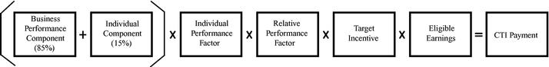

For 2008, the business performance goals were comprised of the following elements:

- corporate EBIAT (40%);

- corporate ROIC (40%); and

- customer loyalty (20%).

Individual contribution is recognized through the individual component and individual performance factor ("IPF"). The IPF is based on a review of each NEO's individual performance relative to business results, teamwork and the executive's key accomplishments. This factor can adjust the executive's actual award by a factor of between 0x and 1.5x.

The Compensation Committee also applies a relative performance factor ("RPF") based on an evaluation of the Corporation's performance for the year relative to that of the EMS Competitors. This evaluation is based on a ROIC-based performance metric but is ultimately within the Compensation Committee's discretion. This factor can adjust the executive's actual award by a factor of between 0.5x and 1.5x.

Actual results relative to the targets, as described above, determine the amount of the annual incentive subject to the following: (i) a minimum corporate profitability threshold must be achieved to pay the business performance component, and (ii) the maximum award is two times the target.

Equity-Based Incentives

The Corporation's equity-based incentives for the NEOs consist of restricted share units ("RSUs"), performance share units ("PSUs") and stock options. The objectives of the equity-based incentive plans are to:

- align interests with those of shareholders and incent appropriate behavior for long-term performance;

- reward contribution to the Corporation's long-term success; and

- enable the Corporation to attract and retain the qualified and experienced employees who are critical to the Corporation's success. At the December meeting, the Compensation Committee determines the dollar value of the equity-based grants to be awarded to the NEOs based on
22

the comparator data analysis. Prior to the January meeting, this amount is converted into the number of units that will be granted using an assumed share price that is determined with reference to the then current trading range of the Corporation's Subordinate Voting Shares. For the 2008 grants, the assumed share price was $4.50. The actual equity mix to be awarded is then approved at the January meeting of the Compensation Committee. The grants are made immediately following the blackout period that ends 48 hours after the Corporation's year end results have been released.

Target equity-based incentives are determined based on the median awards of the Comparator Group; however, consideration is given to individual performance when determining actual awards. The equity mix varies by employee level and targets a higher percentage of performance elements at the NEO levels where there is a stronger influence on results. The target mix of equity-based incentives is reviewed by the Compensation Committee each year and for 2008 the targets for the NEOs were as follows:

- 40% RSUs;

- 35% PSUs; and

- 25% stock options.

The CEO has the discretion to issue equity-based awards throughout the year to attract new hires and to retain current employees within limits set by the Compensation Committee. The number of units available throughout the year for these grants is pre-approved by the Compensation Committee at the January meeting. Subject to the Corporation's blackout periods, these grants typically take place at the beginning of each month. Any grants to senior executives must be reviewed with the Compensation Committee at the next meeting and in practice are reviewed in advance with the Chairman of the Compensation Committee.

RSUs

NEOs are granted RSUs under the Celestica Share Unit Plan ("CSUP"). RSUs granted prior to February 2008 are released on the first day of December two years following the grant (i.e., RSUs granted in February 2007 will be released on December 1, 2009). RSUs granted in February 2008 or later are released one-third on each of the first two anniversaries of the grant date and the final third is released on the first day of December two years following the grant. Each RSU entitles the holder to one Subordinate Voting Share of the Corporation on the release date. The payout value of the award is based on the number of RSUs being released and the share price at the time of release.

PSUs

NEOs are granted PSUs under the CSUP. PSUs vest at the end of a three-year performance period subject to pre-determined performance criteria. The number of PSUs that actually vests will range from 0% to 200% of target depending on the Corporation's ranking in the third year of the performance period relative to that of the EMS Competitors based on an ROIC metric approved by the Compensation Committee. The vesting schedule is outlined in the following table.

Table 10: PSU Vesting Schedule

Celestica's ROIC Metric | Performance Multiplier
Equal to/greater than highest performance of EMS Competitors | 200% of target
Between the median and highest performance | Prorated between 100%-200%
Equal to median performance of EMS Competitors | 100% of target
Between the median and lowest performance | Prorated between 0%-100%
Equal to/lower than lowest performance of EMS Competitors | 0% of target

The payout value of the award is based on the number of PSUs that vests and the share price at the time of release. Each PSU entitles the holder to receive one Subordinate Voting Share of the Corporation on the release date.

23

Stock Options

Stock options are awarded under the Long Term Incentive Plan ("LTIP"). Stock options vest at a rate of 25% annually on the anniversary of the date of grant and expire after a 10-year term. The payout value of the award is equal to the increase, if any, in share price at the time of exercise over the exercise price, which is the closing market price on the business day prior to the date of the grant.

The value of the stock options granted in respect of 2008 was determined at the December meeting of the Compensation Committee using (i) an assumed share price of $4.50, and (ii) a Black-Scholes factor of 0.40 determined using the same methodology as is used to determine Black-Scholes for stock option expensing purposes. The Black-Scholes factor was determined using the following variables: (i) volatility of the price of Subordinate Voting Shares, and (ii) the risk-free rate over the expected life of the options.

In determining the number of options to be granted, the Corporation keeps within a maximum level for both option "burn rate" and "overhang". "Burn rate" refers to the number of shares issued under equity plans in a given year relative to the total number of shares outstanding. "Overhang" refers to the total number of shares reserved for issuance under equity plans at any given time relative to the total number of shares outstanding. The Corporation has significantly reduced the number of stock option grants awarded and currently has an "overhang" of 11.7%. In 2005, the Corporation amended the LTIP to provide that the number of options awarded under the plan in any given year cannot exceed 1.2% of the total number of shares outstanding.

Other Compensation

Benefits

Executives participate in the Corporation's health, dental, pension, life insurance and long-term disability programs. Benefit programs are based on market median levels in the local geography.

Perquisites

Executives are entitled to an annual comprehensive medical at a private health clinic. The Corporation also pays housing expenses for Mr. Muhlhauser in Toronto, travel costs between his home in New Jersey and Toronto, and the services of a tax advisor. The Corporation does not provide any other perquisites.

Celestica Employee Share Ownership Plan (the "CESOP")

The CESOP enables eligible employees, including NEOs, to acquire Subordinate Voting Shares, so as to encourage continued employee interest in the Corporation's operation, growth and development. Under the CESOP, an eligible participant may elect to contribute an amount representing no more than 10% of his or her salary. The Corporation will contribute 25% of the amount that the employee contributes, up to a maximum of 1% of the employee's salary for the relevant payroll period. Contributions are used to purchase Subordinate Voting Shares of the Corporation on the open market.

Executive Share Ownership

The Corporation has share ownership guidelines for the CEO and the other NEOs. The guidelines provide that these individuals are to hold a multiple of their salary in Celestica Subordinate Voting Shares as shown in Table 11 below. Executives subject to ownership guidelines are expected to achieve the specified ownership within a period of five years following the latest of: (i) the date of implementation of the guidelines (January 26, 2005), (ii) the date of hire, or (iii) the date of promotion to a level subject to ownership guidelines. Compliance is reviewed annually as of December 31 of each year.

24

Table 11: Share Ownership Guidelines

Name |  |  |  | Share Ownership | Share
 |  |  |  | Share Ownership | Ownership
 |  | Ownership Guidelines |  | (Value)⁽¹⁾ | (Multiple of Salary)
Craig H. Muhlhauser |  | $3,000,000 | $ | 4,472,548 | 4.5x
 |  | (3 × salary)
Paul Nicoletti |  | $1,024,000 | $ | 1,586,859 | 3.1x
 |  | (2 × salary)
John Peri |  | $1,008,000 | $ | 1,418,681 | 2.8x
 |  | (2 × salary)
Elizabeth L. DelBianco |  | $888,000 | $ | 1,178,265 | 2.7x
 |  | (2 × salary)
John J. Boucher |  | $860,000 | $ | 1,039,716 | 2.4x
 |  | (2 × salary)

- Includes the following, as of December 31, 2008: (i) Subordinate Voting Shares beneficially owned, (ii) all unvested RSUs, (iii) PSUs that vested on January 31, 2009 at 200% of target, which, on December 31, 2008, was the Corporation's anticipated payout and was in fact the resulting payout, and (iv) all other PSUs at 100% of the target level of performance; in each case, the value of which was determined using a share price of $4.61 being the closing price of Subordinate Voting Shares on the NYSE on December 31, 2008.

Recoupment Provisions

The Corporation is subject to the Sarbanes-Oxley Act of 2002. Accordingly, if the Corporation is required to restate financial results due to misconduct or material non-compliance with financial reporting requirements, the CEO and CFO would be required to reimburse the Corporation for any bonuses or incentive-based compensation they had received during the 12-month period following the restatement, as well as any profits they had realized from the sale of corporate securities during that period.

Under the terms of the stock option grants and the grants made under the CSUP plan, a NEO may be required by the Corporation to repay an amount equal to the market value of the shares at the time of release, net of taxes, if, within 12 months of the release date, the executive:

- accepts employment or accepts an engagement to supply services, directly or indirectly, to a third party, that is in competition with the Corporation or any of its subsidiaries; or

- fails to comply with, or otherwise breaches, the terms and conditions of a confidentiality agreement or non-disclosure agreement with, or confidentiality obligations to, the Corporation or any of its subsidiaries; or

- on his or her behalf or on another's behalf, directly or indirectly recruits, induces or solicits, or attempts to recruit, induce or solicit any current employee or other individual who is/was supplying services to the Corporation or any of its subsidiaries.

Executives who resign or are terminated for cause also forfeit all unvested stock options, RSUs and PSUs.

25

2008 Compensation Decisions

Each element of compensation is considered independently of the other elements. However, the total package is reviewed to ensure that the median total compensation objective for median levels of corporate and individual performance is achieved.

Comparator Companies and Market Positioning

Benchmarking for all elements of NEO compensation was based on the Comparator Group. Salary, target annual incentive and equity-based incentive grants for the NEOs were benchmarked at the market median of the Comparator Group.

Base Salary

The base salaries for the NEOs were reviewed taking into account individual performance and experience, level of responsibility and median competitive data.

In 2008, Mr. Muhlhauser's base salary was increased from $750,000 to $1,000,000 to meet the median of the market. Mr. Boucher received a 24.8% increase in base salary as a result of his promotion to Executive Vice President and a significant expansion of his responsibilities. Messrs. Nicoletti and Peri and Ms. DelBianco received increases in the 0% — 3% range as their existing salaries were competitive with the market.

Celestica Team Incentive Plan (CTI)

Target annual incentive awards for the CEO and other NEOs are 100% of salary and 80% of salary, respectively. For 2008, annual incentive payments to the NEOs were paid at the maximum 200% of target incentive due to above average performance that exceeded the Corporation's objectives and the performance of the EMS Competitors on certain metrics described below.

Business Performance

In 2008, the business performance component payout factor was 119% based on the following results:

Table 12: Business Performance

Measure |  |  | Percentage
 |  |  | Achievement
 |  | Weight | Relative to Target
EBIAT⁽¹⁾ |  | 40% | 112%
ROIC, excluding intangibles⁽²⁾ |  | 40% | 136%
Customer Loyalty⁽³⁾ |  | 20% | 100%
Payout Factor |  |  | 119%

- EBIAT was calculated as earnings/loss before interest, amortization of intangible assets, gains or losses on the repurchase of shares and debt, integration costs related to acquisitions, option expense and other charges (most significantly restructuring costs and the write-down of goodwill and long-lived assets) and the related income tax effects of these adjustments.

- ROIC, excluding intangibles, was calculated as EBIAT divided by average net invested capital where average net invested capital includes tangible assets less cash, accounts payable, accrued liabilities and income taxes payable.

- Customer loyalty was measured by a customer relationship index related to a customer's willingness to recommend the Corporation to others or to place new business with the Corporation. Results were based on customer feedback obtained to a large extent through a survey process administered by an independent third-party service provider.

26

Relative Performance Factor (RPF)

The Corporation's 2008 performance was ranked relative to that of the EMS Competitors on a ROIC performance metric. The Corporation ranked first amongst the EMS Competitors which resulted in a RPF that exceeded the 1.5x cap, resulting in the maximum RPF of 1.5x. For this comparison, the Corporation used adjusted ROIC, which is calculated as adjusted net earnings divided by average net invested capital.

Individual Performance Factor (IPF)

Each year, the Board and the CEO agree on performance goals. Goals for the NEOs that will support the CEO's goals are then agreed to and established. For 2008, the CEO's goals focused on: financial performance, customer loyalty, operational effectiveness, growing the business and leadership. Each NEO's performance is then measured on a number of factors including the formal goals established for the year. Specific measures and achievements for each NEO in 2008 were:

Chief Executive Officer

- Financial performance: ROIC grew from 6.4% in 2007 to 13.6% in 2008 and exceeded the target for 2008 by 31%. ROIC for this measure was calculated by dividing EBIAT (as defined in footnote 1 to Table 12) by average net invested capital, including intangibles. Average net invested capital, including intangibles, included total assets less cash, accounts payable, accrued liabilities and income taxes payable.

- Customer loyalty: Customer loyalty improved from 2007 and met the target of 83% for 2008.

- Operational effectiveness: Total spend, as a percentage of manufacturing value add, decreased by 5.6% as compared to 2007 and exceeded the targeted reduction for 2008 by 1.3%.

- Growing the business: The revenue objective was not met but the bookings objective was met at target.

- Leadership: The goal of improving the employee commitment index was not achieved.

In addition to the goals listed above, the Committee's assessment of Mr. Muhlhauser's performance in 2008 reflected outstanding results in a number of non-GAAP areas.

In 2008, the Corporation achieved:

- 200% year-over-year improvement in adjusted earnings per share;

- year-over-year EBIAT growth of approximately 75%;

- its best adjusted gross margin (7.0%) since 2001;

- its best operating margin (3.0%) since 2002;

- its best ROIC (13.6%) since 2000;

- its best ever inventory turns (8.8x) for the Corporation;

- outstanding performance relative to that of the EMS Competitors;

- highest adjusted ROIC (including intangibles);

- highest inventory turns;

- second highest adjusted gross margins; and

- second highest operating margins.

The Committee assessed Mr. Muhlhauser's IPF at the maximum of 1.5x reflecting the Corporation's strong performance in 2008.

Other NEOs

Each of the NEOs has responsibility for the achievement of the CEO's corporate goals and objectives. The CEO's assessment of each of the NEO's contributions to the Corporation's results is largely subjective and based on his judgment of the NEO's contributions as a part of the senior leadership team. The achievement of individual goals is not quantitatively tied to compensation; however, the CEO's overall assessment of each NEO's contributions is used to determine the IPF.

27

Other factors considered in the evaluation of each NEO included the following. Under the leadership of Mr. Nicoletti (who received an IPF of 1.4), the Corporation's financial performance on a number of metrics improved significantly. The Corporation met or exceeded its earnings guidance for each quarter of 2008, generated operating cash flow significantly above expectations and the Corporation's credit outlooks with credit agencies were upgraded. Under the leadership of global operations by Mr. Peri (who received an IPF of 1.2), the Corporation made significant productivity and quality improvements while meeting or exceeding customer satisfaction targets. Global operations contributed to earnings growth and increased customer satisfaction through significant improvements in the Corporation's overall operations. Under the leadership of Ms. DelBianco (who received an IPF of 1.2), the functions for which she is responsible made significant contributions in the areas of human resources and legal strategy, contract training, dispute resolution, customer support, governance and compliance initiatives and leadership development. The Corporation's talent management programs were significantly enhanced and the global incentive plan for production employees was redesigned for 2009. Under the leadership of Mr. Boucher (who received an IPF of 1.3), the supply chain function was reorganized to create a supply chain solutions organization encompassing solutions development and integrated service offerings spanning design, fulfillment, after-market service and automated manufacturing services. In addition, the sales team, under his leadership, contributed to the revenue growth of some of our largest customers.

Equity-Based Incentives

Equity grants to NEOs in respect of 2008 performance consisted of RSUs, PSUs and stock options. The number of RSUs, PSUs and options to be issued to the NEOs was based on an assumed share price of $4.50, which was derived from the trading range of the Corporation's Subordinate Voting Shares prior to the January Compensation Committee meeting. The actual mix of the grants was approved by the Compensation Committee at a meeting on January 28, 2009 and the grants were issued on February 3, 2009.

The Corporation provided the NEOs the following equity-based compensation in February 2009 in respect of 2008 performance.

Table 13: NEO Equity Awards

 |  |  |  |  |  | Intended
 |  |  |  |  |  | Compensatory
Name |  | RSUs | PSUs⁽¹⁾ | Stock Options |  | Value of LTI
 |  | (#) | (#) | (#) |  | Award⁽²⁾
Craig H. Muhlhauser |  | 444,444 | 388,889 | 694,444 | $ | 5,000,000
Paul Nicoletti |  | 160,000 | 140,000 | 250,000 | $ | 1,800,000
John Peri |  | 133,333 | 116,667 | 208,333 | $ | 1,500,000
Elizabeth L. DelBianco |  | 133,333 | 116,667 | 208,333 | $ | 1,500,000
John J. Boucher |  | 133,333 | 116,667 | 208,333 | $ | 1,500,000

- The number of PSUs is included at 100% of target level of performance.

- Based on the assumed $4.50 share price at the time the grant was approved by the Compensation Committee and, with respect to stock options, a Black-Scholes factor of 0.40.

Please see the discussion regarding Compensation Discussion and Analysis — Equity-Based Incentives on page 22 regarding the calculation, terms and vesting schedules of equity awards.

28

Performance Graph

The Subordinate Voting Shares of the Corporation have been listed and posted for trading under the symbol "CLS" on the NYSE and the TSX since June 30, 1998 (except for the period commencing on November 8, 2004 and ending on May 15, 2006 during which the symbol on the TSX has been CLS.SV). The following chart compares the cumulative total shareholder return of C$100 invested in Subordinate Voting Shares of the Corporation on December 31, 2003

(the Corporation did not declare or pay any dividends during this period) with the cumulative total shareholder return of the S&P/TSX Composite Index for the period December 31, 2003 to December 31, 2008.
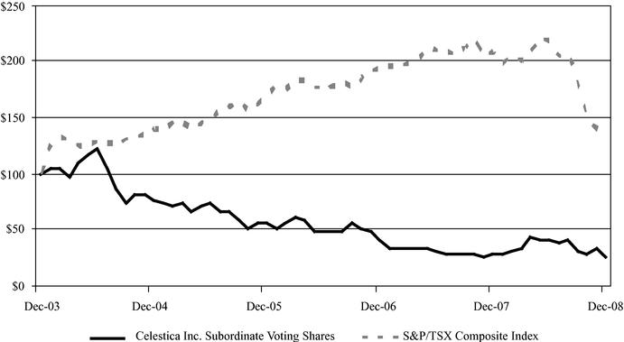

As can be seen from the performance above, an investment in the Corporation on January 1, 2004 would have resulted in a 74% loss in value over the five-year period ended December 31, 2008 compared with a 36% increase that would have resulted from an investment in the S&P/TSX Composite Index over the same period.

The compensation of the Corporation's NEOs has fluctuated over the same period as the Corporation dealt with, amongst other things, competitive pressures, operational issues, significant restructuring and various leadership changes. In 2005, total compensation for NEOs decreased by 46% compared to 2004, from $21.1 million to $11.3 million and, in 2006, by a further 57% compared to the previous year, to $4.9 million (excluding severance costs). The reduction in total compensation for NEOs was largely attributable to reduced long-term incentive grants to certain NEOs. In 2006, total annual compensation for NEOs during this five-year period reached its lowest point and was 77% less than that paid in 2004.

After significant operational challenges were experienced in the second half of 2006, senior management changes were made across the Corporation. The new management team implemented major process improvements across all areas of the Corporation with a specific focus on improving profitability, reducing working capital and strengthening the Corporation's financial position. As management has implemented these changes during 2007 and 2008, the Corporation's operating performance and financial results have shown significant improvements to the point where the Corporation was the strongest financial performer amongst the EMS Competitors by the end of 2008. The Corporation's performance over this two-year period was its best operating performance during the

29

past six years, as well as its being amongst the best performers in the EMS industry on key operating performance metrics. This strong financial performance also contributed to improved outlooks from the Corporation's key financial rating agencies and multi-year highs in customer satisfaction levels. The performance graphs set out below illustrate the Corporation's significant improvements on non-GAAP measures of gross margins, operating margins, asset utilization and ROIC.

Gross margins

% of revenue
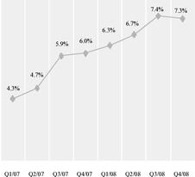

Excluding non-cash option expense

Asset utilization

Inventory turns
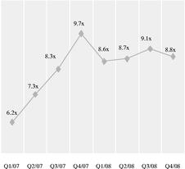

During this period of improved performance, total compensation for the NEOs increased to $15.2 million in 2007 and $19.8 million in 2008. These increases were a result of implementing competitive compensation packages for the Corporation's leadership team, as well as maximum annual incentive payouts due to strong corporate performance in 2008. In 2008, total compensation for NEOs was 6% less than that paid in 2004.

Operating margins

% of revenue
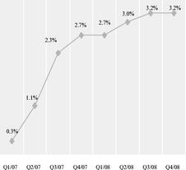

Excluding non-cash option expense

Return on invested capital

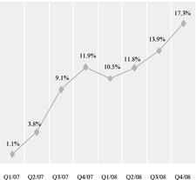

Including Intangible assets

30

EXECUTIVE COMPENSATION

Compensation of Named Executive Officers

The following table sets forth the compensation of the Corporation's Chief Executive Officer, Chief Financial Officer and the three other most highly compensated executives of the Corporation and its subsidiaries (collectively, the "Named Executive Officers" or "NEOs") for the financial year ended December 31, 2008.

In light of the significant changes to the requirements, content and format for executive compensation disclosure made by the Canadian Securities Administrators applicable to issuers with a December 31, 2008 or later year end, the Corporation has disclosed executive compensation in the Summary Compensation table below for the financial year ended December 31, 2008 only, in accordance with these requirements. Disclosure of executive compensation for prior years, in accordance with then applicable requirements, is contained in the Corporation's previous management information circular dated March 9, 2008, which is available on www.sedar.com.

Table 14: Summary Compensation for 2008

 |  |  |  |  | Non-Equity Incentive
 |  |  |  |  | Plan Compensation
Name & Principle Position |  |  | Share-Based | Option-Based | Annual Incentive | Pension | All Other
 |  | Salary | Awards | Awards | Plans | Value | Compensation | Total Compensation
 |  | ($) | _{($)}(1)(3) | _{($)}(2)(3) | ($)⁽⁴⁾ | ($) | ($)⁽⁵⁾ | ($)
Craig H. Muhlhauser |  | $937,500 | $3,750,000 | $1,250,000 | $2,000,000 | $13,800 | $168,278 | $8,119,578
President and Chief Executive Officer
Paul Nicoletti⁽⁶⁾ |  | $507,562 | $1,350,000 | $450,000 | $818,056 | $48,180 | $16,982 | $3,190,780
EVP, Chief Financial Officer
John Peri⁽⁶⁾ |  | $503,977 | $1,125,000 | $375,000 | $806,364 | $41,959 | $298,286 | $3,150,586
EVP, Global Operations
Elizabeth L. DelBianco⁽⁶⁾ |  | $439,924 | $1,125,000 | $375,000 | $709,042 | $33,906 | $17,274 | $2,700,146
EVP, Chief Legal & Administrative Officer and
Corporate Secretary
John J. Boucher⁽⁷⁾ |  | $422,525 | $1,125,000 | $375,000 | $673,667 | $10,278 | $1,431 | $2,607,901
EVP, Supply Chain Management Solutions &
CPO

- Amounts in the column represent the value of RSUs and PSUs granted on February 3, 2009 under the CSUP in respect of 2008 performance. The value shown is the value intended to be paid to the NEO. The actual number of RSUs and PSUs granted was based on an assumed share price of $4.50 when the grants were approved by the Compensation Committee. Please see Compensation and Discussion Analysis — Equity-Based Incentives on page 22 for a description of the vesting terms of the awards and the process followed in determining the grant. The value included for PSUs is at 100% of target level performance. The number that will actually vest will vary from 0%-200% of the target grant depending on performance.

- Amounts in the column represent the value of stock options that were issued under the LTIP on February 3, 2009 in respect of 2008 performance. The value shown is the value intended to be paid to the NEO. The actual number of options granted was based on an assumed share price of $4.50 when the grants were approved by the Compensation Committee. Please see Compensation and Discussion Analysis — Equity-Based Incentives on page 22 for a description of the vesting terms of the awards and the process followed in determining the value of the grant.

- The accounting fair value of the equity-based awards is calculated using a share price of $4.13, which was the closing price of the Subordinate Voting Shares on the NYSE on February 2, 2009, the day before the grants were actually made. Based on this share price, the accounting fair value of the total of share-based and option-based awards to the NEOs during 2008 are as follows:
Mr. Muhlhauser — $4,589,000; Mr. Nicoletti — $1,652,000; Mr. Peri —

31

$1,377,000; Ms. DelBianco — $1,377,000; and Mr. Boucher — $1,377,000.

- Amounts in this column represent incentive payments made to the NEOs through the CTI Plan. Please see Compensation and Discussion Analysis — Celestica Team Incentive Plan ("CTI") on page 22 for a description of the plan and the results achieved in respect of 2008.

- Amounts in this column represent: (i) contributions to the CESOP for Messrs. Muhlhauser and Peri (see Celestica Employee Share Ownership Plan on page 24), (ii) for Mr. Muhlhauser, tax equalization and tax gross-up payments of $97,692, housing expenses while in Canada and travel expenses between Toronto and New Jersey, and (iii) for Mr. Peri, expenses related to his foreign assignment and subsequent repatriation that include cost of living allowance, housing and moving expenses of $176,510 and tax equalization payments of $81,314.

- The compensation of Messrs. Nicoletti and Peri and Ms. DelBianco is paid in Canadian dollars. Their compensation is reported in US dollars using a currency exchange rate of C$1.00/ $0.9381, being the average currency exchange rate for 2008.

- Mr. Boucher was promoted to Executive Vice President on February 1, 2008. Prior to this date, he was a Senior Vice President. His target incentive for 2008 was 78.3% prorated at 60% for one month and 80% for 11 months.

32

The following table provides details of each option grant outstanding and the aggregate number of unvested equity-based awards for each of the Named Executive Officers as of December 31, 2008.

Table 15: Outstanding Option-Based and Share-Based Awards⁽¹⁾

 |  |  |  |  |  | Market | Market | Market
 |  |  |  |  |  | Payout | Payout | Payout
 |  |  |  |  |  | Value of | Value of | Value of
 | Number of |  |  |  | Number of | Share | Share | Share
 | Securities |  |  | Value of | Shares or | Awards that | Awards that | Awards that
 | Underlying | Option |  | Unexercised | Units that | have not | have not | have not
Name | Unexercised | Exercise | Option | In-the-money | have not | Vested at | Vested at | Vested at
Name | Options | Price | Expiration | Options | Vested | Minimum | Target | Maximum
 | (#) | ($) | Date | ($) | (#) | ($)⁽²⁾ | ($)⁽²⁾ | ($)⁽²⁾
Craig H. Muhlhauser
Jun. 6, 2005 | 50,000 | $13.00 | Jun. 6, 2015 | — | — | — | — | —
Jan. 31, 2006 | 74,244* | $10.00 | Jan. 31, 2016 | — | 63,000 | — | $290,430 | $580,860
Feb. 2, 2007 | 500,000 | $6.05 | Feb. 2, 2017 | — | 167,000 | $258,160 | $769,870 | $1,281,580
Feb. 2, 2007 | 202,000* | $6.05 | Feb. 2, 2017 | — | — | — | — | —
Feb. 5, 2008 | 450,000 | $6.51 | Feb. 5, 2018 | — | 592,500 | $1,694,175 | $2,731,425 | $3,768,675
Feb. 3, 2009 | 694,444 | $4.13 | Feb. 3, 2019 | — | 833,333 | $1,835,554 | $3,441,665 | $5,047,777
Paul Nicoletti
Jan. 1, 1999 | 5,600 | C$20.63 | Jan. 1, 2009 | — | — | — | — | —
Dec. 3, 2002 | 15,000 | C$29.11 | Dec. 3, 2012 | — | — | — | — | —
Jan. 31, 2004 | 13,333 | C$22.75 | Jan. 31, 2014 | — | — | — | — | —
May 11, 2004 | 3,333 | C$24.92 | May 11, 2014 | — | — | — | — | —
Dec. 9, 2004 | 13,600 | C$18.00 | Dec. 9, 2014 | — | — | — | — | —
Jan. 31, 2006 | 21,591 | C$11.43 | Jan. 31, 2016 | — | 19,000 | — | $87,590 | $175,180
Feb. 2, 2007 | 37,880 | C$7.10 | Feb. 2, 2017 | — | 48,610 | $160,068 | $224,092 | $288,116
May 7, 2007 | — | — | — | — | 10,700 | $49,327 | $49,327 | $49,327
Jul. 31, 2007 | 91,500 | C$6.27 | Jul. 31, 2017 | — | 15,000 | $69,150 | $69,150 | $69,150
Feb. 5, 2008 | 150,000 | C$6.51 | Feb. 5, 2018 | — | 197,500 | $564,725 | $910,475 | $1,256,225
Feb. 3, 2009 | 250,000 | C$5.13 | Feb. 3, 2019 | — | 300,000 | $660,800 | $1,239,000 | $1,817,200
John Peri
Jan. 1, 1999 | 9,000 | C$20.63 | Jan. 1, 2009 | — | — | — | — | —
Dec. 3, 2002 | 25,000 | C$29.11 | Dec. 3, 2012 | — | — | — | — | —
Jan. 31, 2004 | 16,667 | C$22.75 | Jan. 31, 2014 | — | — | — | — | —
Dec. 9, 2004 | 11,300 | C$18.00 | Dec. 9, 2014 | — | — | — | — | —
Jan. 31, 2006 | 20,455 | C$11.43 | Jan. 31, 2016 | — | 18,000 | — | $82,980 | $165,960
Feb. 2, 2007 | 40,404 | C$7.10 | Feb. 2, 2017 | — | — | — | — | —
Feb. 2, 2007 | 80,808* | C$7.10 | Feb. 2, 2017 | — | 44,444 | — | $204,887 | $409,774
Feb. 5, 2008 | 130,000 | C$6.51 | Feb. 5, 2018 | — | 171,167 | $489,430 | $789,080 | $1,088,730
Feb. 3, 2009 | 208,333 | C$5.13 | Feb. 3, 2019 | — | 250,000 | $550,665 | $1,032,500 | $1,514,335
Elizabeth L. DelBianco
Jan. 1, 1999 | 9,000 | C$20.63 | Jan. 1, 2009 | — | — | — | — | —
Dec. 3, 2002 | 12,000 | C$29.11 | Dec. 3, 2012 | — | — | — | — | —
Dec. 18, 2002 | 3,000 | C$23.29 | Dec. 18, 2012 | — | — | — | — | —
Apr. 18, 2003 | 8,000 | C$15.35 | Apr. 18, 2013 | — | — | — | — | —
Jan. 31, 2004 | 16,667 | C$22.75 | Jan. 31, 2014 | — | — | — | — | —
Dec. 9, 2004 | 11,300 | C$18.00 | Dec. 9, 2014 | — | — | — | — | —
Jan. 31, 2006 | 21,591 | C$11.43 | Jan. 31, 2016 | — | 19,000 | — | $87,590 | $175,180
Feb. 2, 2007 | 36,364 | C$7.10 | Feb. 2, 2017 | — | 46,666 | $153,665 | $215,130 | $276,595
Feb. 5, 2008 | 120,000 | C$6.51 | Feb. 5, 2018 | — | 158,000 | $451,780 | $728,380 | $1,004,980
Feb. 3, 2009 | 208,333 | C$5.13 | Feb. 3, 2019 | — | 250,000 | $550,665 | $1,032,500 | $1,514,335
John J. Boucher
Jan. 1, 1999 | 1,406 | $12.80 | Jan. 1, 2009 | — | — | — | — | —
Jan. 20, 1999 | 1,050 | $10.67 | Jan. 20, 2009 | — | — | — | — | —
Oct. 13, 2000 | 3,750 | $21.83 | Oct. 13, 2010 | — | — | — | — | —
May 22, 2001 | 6,000 | $19.81 | May 22, 2011 | — | — | — | — | —
Oct. 31, 2001 | 3,750 | $10.40 | Oct. 31, 2011 | — | — | — | — | —
May 10, 2002 | 28,125 | $13.52 | May 10, 2012 | — | — | — | — | —
Feb. 11, 2003 | 5,625 | $12.99 | Feb. 11, 2013 | — | — | — | — | —
Mar. 15, 2004 | 20,000 | $17.10 | Mar. 15, 2014 | — | — | — | — | —
Mar. 15, 2004 | 6,667 | $17.10 | Mar. 15, 2014 | — | — | — | — | —
Dec. 9, 2004 | 25,000 | $14.86 | Dec. 9, 2014 | — | — | — | — | —
Jan. 31, 2006 | 20,455 | $10.00 | Jan. 31, 2016 | — | 18,000 | — | $82,980 | $165,960
Feb. 2, 2007 | 30,304 | $6.05 | Feb. 2, 2017 | — | 38,888 | $102,443 | $179,274 | $256,104
Feb. 5, 2008 | 110,000 | $6.51 | Feb. 5, 2018 | — | 144,800 | $413,978 | $667,528 | $921,078
Feb. 3, 2009 | 208,333 | $4.13 | Feb. 3, 2019 | — | 250,000 | $550,665 | $1,032,500 | $1,514,335

33

- Denotes Performance Contingent Options ("PCOs") which are not fully vested and are included at 100% of target level performance. PCOs have not been issued since February 2007 and the Corporation does not contemplate issuing further PCOs.

- Includes options and share-based awards granted on February 3, 2009 in respect of 2008 performance. Please see Compensation Discussion and Analysis — Equity-Based Incentives on page 22 for a discussion of the equity grants.

- Market payout values at minimum vesting include the value of RSUs only as the minimum payout value of PSUs would be 0% of target. Market payout values at target vesting is determined using 100% of PSUs vesting and market payout values at maximum vesting is determined using 200% of PSUs vesting. Market payout values are determined using a share price of $4.61, which was the closing price of the Subordinate Voting Shares on the NYSE on December 31, 2008, except for the share-based awards granted on February 3, 2009 in respect of 2008 performance for which the market payout values are determined using a share price of $4.13, which was the closing price of the Subordinate Voting Shares on the NYSE on February 2, 2009, the day before the grants.

The following table provides details of the value of option-based and share-based awards that vested during 2008 and the value of annual incentive awards paid for 2008 performance for each Named Executive Officer.

Table 16: Incentive Plan Awards — Value Vested or Earned in 2008

 |  | Option-Based | Share-Based | Non-Equity Incentive Plan
 |  | Awards — Value Vested | Awards — Value Vested | Compensation — Value
Name |  | During the Year⁽¹⁾ | During the Year⁽²⁾ | Earned During the Year⁽³⁾
 |  | ($) | ($) | ($)
Craig H. Muhlhauser |  | $57,500 | $1,010,160 | $2,000,000
Paul Nicoletti |  | $39,269 | $103,565 | $818,056
John Peri |  | — | $95,298 | $806,364
Elizabeth L. DelBianco |  | — | $99,449 | $709,042
John J. Boucher |  | $3,485 | $108,449 | $673,667

- None of the options that vested in 2008 was exercised by the NEOs. Values shown are as of the vesting date. Options for Messrs. Muhlhauser and Boucher vested on February 2, 2008 with an exercise price of $6.05. The share price for the Corporation's Subordinate Voting Shares on the NYSE was $6.51 on that date. Options for Mr. Nicoletti vested on July 31, 2008 with an exercise price of C$6.27. The price for the Corporation's Subordinate Voting Shares on the TSX was C$8.10 on that date. None of these options are now in-the-money.

- Share-based awards were released as follows: (i) RSUs were released to Mr. Muhlhauser on June 1, 2008 at a price of $8.78 and to all NEOs, including Mr. Muhlhauser, on December 1, 2008 at a price of $4.72 on the NYSE for Messrs. Boucher and Muhlhauser and C$5.90 on the TSX for Messrs. Nicoletti and Peri and Ms. DelBianco, and (ii) PSUs were released to all NEOs, except Mr. Muhlhauser, on January 31, 2008 at a price of $5.63 on the NYSE for Mr. Boucher and C$5.85 on the TSX for Messrs. Nicoletti and Peri and Ms. DelBianco.

- Includes payments under the CTI Plan made in February 2009 in respect of 2008 performance. Please see Compensation Decisions — Celestica Team Incentive Plan (CTI) on page 22. These are the same amounts as disclosed in Table 14 under the column "Non-Equity Incentive Plan Compensation — Annual Incentive Plans".

34

Pension Plans

The following table provides details of the amount of the Celestica contributions to the pension plans and the accumulated value as of December 31, 2008 for each Named Executive Officer.

Table 17: Defined Contribution Pension Plan

Name |  | Accumulated Value |  | Non-compensatory⁽¹⁾ | Accumulated Value
 |  | at Start of Year | Compensatory | Non-compensatory⁽¹⁾ | at Year End
 |  | ($) | ($) | ($) | ($)
Craig H. Muhlhauser |  | $61,788 | $13,800 | $(2,692) | $72,896
Paul Nicoletti |  | $211,569 | $48,180 | $(77,511) | $182,238
John Peri |  | $477,826 | $41,959 | $(132,563) | $387,222
Elizabeth L. DelBianco |  | $183,265 | $33,906 | $(44,267) | $172,904
John J. Boucher |  | $326,205 | $10,278 | $(129,357) | $207,126

- Non-compensatory changes are shown as a loss as a result of the negative performance of the investment earnings during the year.

Messrs. Muhlhauser and Boucher participate in the "US Plan". The US Plan is a defined contribution pension plan and qualifies as a deferred salary arrangement under section 401(k) of the Internal Revenue Code (United States). Under the US Plan, participating employees may defer 100% of their pre-tax earnings subject to any statutory limitations. The Corporation may make contributions for the benefit of eligible employees. The US Plan allows employees to choose how their account balances are invested on their behalf within a range of investment options provided by third party fund managers. The Corporation contributes: (i) 3% of eligible compensation for Messrs. Muhlhauser and Boucher, and (ii) up to an additional 3% of eligible compensation by matching 50% of the first 6% contributed by each of them. The maximum contribution of the Corporation based on the Internal Revenue Code rules and the plan formula for 2008 is $13,800. There are no supplemental plans for US employees.

Messrs. Nicoletti and Peri and Ms. DelBianco participate in the defined contribution portion of the Canadian Pension Plan. The defined contribution portion of the Canadian Pension Plan allows employees to choose how the Corporation's contributions are invested on their behalf within a range of investment options provided by third party fund managers. The Corporation's contributions to this plan on behalf of an NEO range from 3.6% to 6.75% of salary and paid annual incentive based on the number of years of service. Retirement benefits depend upon the performance of the investment options chosen. Messrs. Nicoletti and Peri and Ms. DelBianco also participate in an unregistered supplementary pension plan (the "Supplementary Plan") that is also a defined contribution plan that is designed to provide benefits equal to the difference between the benefits determined in accordance with the formula set out in the Canadian Pension Plan and Canada Revenue Agency maximum pension benefits. Notional accounts are maintained for each participant in the Supplementary Plan. Participants are entitled to select from among the investment options available in the registered plan for the purpose of determining the return on their notional accounts.

The 2008 percentage contribution rates are outlined below in Table 18.

 | Table 18: Celestica Contributions
 | to the Canadian Pension Plan
Name
 | Contribution %
Paul Nicoletti | 6.25%
John Peri | 6.30%
Elizabeth L. DelBianco | 5.33%
 | 35

Termination of Employment and Change in Control Arrangements with Named Executive Officers

The Corporation has entered into employment agreements with certain of its NEOs in order to provide for certainty to the Corporation and such NEO with respect to such things as obligations of confidentiality, non-solicitation and non-competition after termination of employment, the amount of severance to be paid in the event the employment of an NEO is terminated and to provide a retention incentive in the event of a change in control scenario.

Messrs. Muhlhauser and Nicoletti and Ms. DelBianco

The employment agreements of the above-noted individuals provide that each of them is entitled to certain severance benefits if, during a change in control period at the Corporation (defined in their agreements as the period commencing on the date the Corporation enters into a binding agreement for a change in control, announces an intention to effect a change in control or the board adopts a resolution that a change in control has occurred and ending three years after the completion of the change in control or, if a change in control is not completed, one year following the commencement of the period), they are terminated without cause or resign for reasons specified in their agreements. The amount of the severance payment for Mr. Muhlhauser is equal to three times his annual base salary and the simple average of his annual incentive for the three prior completed financial years of the Corporation, together with a portion of his expected annual incentive for the year prorated to the date of termination. The amount of the severance payment for each of Mr. Nicoletti and Ms. DelBianco is equal to three times their annual base salary and target annual incentive, together with a portion of their target annual incentive for the year prorated to the date of termination. In addition, the agreements provide for a cash settlement to cover benefits that would otherwise be payable during the severance period, and the continuation of contributions to their pension and retirement plans until the third anniversary following their termination.

Upon a change in control or upon termination without cause during a change in control period or resignation for reasons specified in their agreements during a change in control period, (a) the options granted to each of them vest immediately, (b) the PCOs and PSUs granted to each of them vest immediately at target level of performance, unless the terms of a PCO or PSU grant provide otherwise, or on such other more favorable terms as the Board in its discretion may provide, and (c) the RSUs granted to each of them shall vest immediately.

Outside a change in control period, upon termination without cause or resignation for reasons specified in their agreements, the amount of the severance payment for Mr. Muhlhauser is equal to two times his annual base salary and the simple average of his annual incentive for the two prior completed financial years of the Corporation, together with a portion of his expected annual incentive for the year prorated to the date of termination. The amount of the severance payment for each of Mr. Nicoletti and Ms. DelBianco is equal to two times their annual base salary and target annual incentive, together with a portion of their target annual incentive for the year prorated to the date of termination. There is no accelerated vesting of options, PCOs or PSUs and all unvested options, PCOs and PSUs are cancelled. All RSUs shall vest immediately on a pro rata basis based on the number of full years of employment completed between the date of grant and the termination of employment. In addition, the Corporation's obligations provide for a cash settlement to cover benefits and contributions to or continuation of their pension and retirement plans for a two-year period following termination. In the event of retirement, the number of RSUs and PSUs vest on a prorated basis based on the number of days between the date of grant and the date of retirement.

The following tables summarize the payments to which Messrs. Muhlhauser and Nicoletti and Ms. DelBianco would have been entitled upon a change in control, or if their employment had been terminated on December 31, 2008 as a result of a change in control, retirement or termination without cause.

36

Table 19: Mr. Muhlhauser's Benefits

 |  | Cash | Value of | Other
 |  | Cash | Exercisable/ | Other
 |  | Portion⁽¹⁾ | Vested LTIP | Benefits⁽²⁾ | Total
Change in Control — No Termination |  | — | $3,791,725 | — | $3,791,725
Change in Control — Termination |  | $5,034,060 | $3,791,725 | $69,408 | $8,895,193
Retirement |  | — | $1,921,890 | — | $1,921,890
Termination without Cause |  | $3,796,996 | $86,053 | $47,586 | $3,930,635

- Cash portion includes actual CTI payment for 2008.

- Other benefits include group health and welfare benefits and 401(k) contribution. There are no incremental benefits resulting from resignation or termination with cause.

Table 20: Mr. Nicoletti's Benefits

 |  | Cash | Value of | Other
 |  | Cash | Exercisable/ | Other
 |  | Portion⁽¹⁾ | Vested LTIP | Benefits⁽²⁾ | Total
Change in Control — No Termination |  | — | $1,541,348 | — | $1,541,348
Change in Control — Termination |  | $3,169,966 | $1,541,348 | $204,399 | $4,915,713
Retirement |  | — | $764,185 | — | $764,185
Termination without Cause |  | $2,249,653 | $106,749 | $133,874 | $2,490,276

- Cash portion includes actual CTI payment for 2008.

- Other benefits include group health benefits and pension plan contribution. There are no incremental benefits resulting from resignation or termination with cause.

Table 21: Ms. DelBianco's Benefits

 |  | Cash | Value of | Other
 |  | Cash | Exercisable/ | Other
 |  | Portion⁽¹⁾ | Vested LTIP | Benefits⁽²⁾ | Total
Change in Control — No Termination |  | — | $1,185,472 | — | $1,185,472
Change in Control — Termination |  | $2,747,538 | $1,185,472 | $160,615 | $4,093,625
Retirement |  | — | $622,781 | — | $622,781
Termination without Cause |  | $1,949,865 | $58,890 | $104,686 | $2,113,441

- Cash portion includes actual CTI payment for 2008.

- Other benefits include group health benefits and pension plan contribution. There are no incremental benefits resulting from resignation or termination with cause.

Messrs. Peri and Boucher

The terms of employment with the Corporation for Messrs. Peri and Boucher are governed by the Corporation's Executive Policy Guidelines (the "Executive Guidelines"). Upon termination without cause or resignation for reasons specified in the Executive Guidelines within two years following a change in control of the Corporation, Messrs. Peri and Boucher are entitled to a severance payment equal to two times annual base salary and the lower of target or actual annual incentive for the previous year, subject to adjustment for factors including length of service, together with a portion of his

37

annual incentive for the year prorated to the date of termination.

Under the Executive Guidelines, the pension and group benefits of Messrs. Peri and Boucher discontinue on the date of termination. In addition, upon a change in control or upon termination without cause or resignation for reasons specified in the Executive Guidelines within two years following a change in control (a) all options granted to Messrs. Peri and Boucher vest immediately, (b) the RSUs granted to them vest immediately, and (c) the PSUs granted to them vest immediately at target level of performance.

Outside of the two-year period following a change in control, upon termination without cause, Messrs. Peri and Boucher are entitled to payments and benefits that are substantially similar to those provided following a termination within two years of a change in control, except that awards vest according to plan provisions with no accelerated vesting of options and PSUs. RSUs vest immediately on a pro-rata basis based on the full number of years of employment completed between the date of grant and the date of termination. In the event of retirement, the number of RSUs and PSUs vest on a prorated basis based on the number of days between the date of grant and the date of retirement.

The following tables summarize the payments to which Messrs. Peri and Boucher would have been entitled upon a change in control, or if their employment had been terminated on December 31, 2008 as a result of a change in control, retirement or termination without cause.

Table 22: Mr. Peri's Benefits

 |  |  | Cash | Value of
 |  |  | Cash | Exercisable/ | Other
 |  |  | Portion⁽¹⁾ | Vested LTIP | Benefits | Total
Change in Control — No Termination |  |  | — | $1,238,182 | — | $1,238,182
Change in Control — Termination |  |  | $1,534,523 | $1,238,182 | — | $2,772,705
Retirement |  |  | — | $620,195 | — | $620,195
Termination without Cause |  |  | $1,534,523 | — | — | $1,534,523
(1) | Cash portion includes actual CTI payment for 2008.
 |  |  | Table 23: Mr. Boucher's Benefits
 |  |  | Cash | Value of
 |  |  | Cash | Exercisable/ | Other
 |  |  | Portion⁽¹⁾ | Vested LTIP | Benefits | Total
Change in Control — No Termination |  |  | — | $929,782 | — | $929,782
Change in Control — Termination |  |  | $1,295,698 | $929,782 | — | $2,225,480
Retirement |  |  | — | $488,833 | — | $488,833
Termination without Cause |  |  | $1,295,698 | $34,148 | — | $1,329,846

- Cash portion includes actual CTI payment for 2008.

Securities Authorized for Issuance Under Equity Compensation Plans

Table 24: Equity Compensation Plans as at December 31, 2008

 |  |  |  | Securities Remaining
 |  | Securities to be |  | Available for Future
 |  | Issued Upon Exercise | Weighted-Average | Issuance Under
 |  | of Outstanding | Exercise Price of | Equity
 |  | Options, Warrants | Outstanding Options, | Compensation
Plan Category |  | and Rights | Warrants and Rights | Plans⁽¹⁾
 |  | (#) | ($) | (#)
Equity Compensation | Manufacturers' Services | 213,735 | $15.46 | 0
Plans Approved by | Limited (MSL) (plan
Securityholders | acquired as part of
 | acquisition)
 | LTIP (Options) | 8,930,465 | $11.88/C$15.88 | 18,781,037
 | LTIP (RSUs) | 62,500 | N/A | 1,016,940
 | Total⁽²⁾ | 9,206,700 | $12.23/C$15.88 | 19,797,977
Equity Compensation Plans Not Approved by |  | 7,644,577 | N/A | N/A
Securityholders

Total: 16,851,277 N/A 19,797,977

- Excluding securities that may be issued upon exercise of outstanding options, warrants and rights.

- The total number of securities to be issued under all equity compensation plans approved by shareholders represent 4.02% of the total number of outstanding shares (MSL — 0.09%; LTIP (Options) — 3.90%; and LTIP (RSUs) — 0.03%).

The LTIP is the only securities-based compensation plan providing for the issuance of securities from treasury under which grants have been made and continue to be made by the Corporation since the company was listed on the TSX. Under the LTIP, the Board of Directors may in its discretion grant from time to time stock options, performance shares, performance share units and stock appreciation rights ("SARs") to employees and consultants, the eligible participants, of the Corporation and affiliated entities.

Under the LTIP, up to 29,000,000 Subordinate Voting Shares may be issued from treasury. The number of Subordinate Voting Shares which may be issued from treasury under the LTIP to directors is limited to 2,000,000; however, no more option grants under the LTIP will be made to directors. Under the LTIP, as of February 23, 2009, 2,209,058 Subordinate Voting Shares have been issued from treasury and 10,931,090 Subordinate Voting Shares are issuable under outstanding options. Also as of February 23, 2009, 26,790,942 Subordinate Voting Shares are reserved for issuance from treasury under the LTIP. In addition, the Corporation may satisfy obligations under the LTIP by acquiring Subordinate Voting Shares in the market.

The LTIP limits the number of Subordinate Voting Shares that may be (a) reserved for issuance to insiders (as defined under TSX rules for this purpose), and

- issued within a one-year period to insiders pursuant to options or rights granted pursuant to the LTIP, together with Subordinate Voting Shares reserved for issuance under any other employee-related plan of the Corporation or options for services granted by the Corporation, in each case to 10% of the aggregate issued and outstanding Subordinate Voting Shares and MVS of the Corporation. The LTIP also limits the number of Subordinate Voting Shares which may be reserved for issuance to any one participant pursuant to options or SARs granted pursuant to the LTIP, together with Subordinate Voting Shares reserved for

38

issuance under any other employee-related plan of the Corporation or options for services granted by the Corporation, to 5% of the aggregate issued and outstanding Subordinate Voting Shares and MVS of the Corporation. The number of grants awarded under the LTIP in any given year cannot exceed 1.2% of the total number of Subordinate Voting Shares.

Options issued under the LTIP may be exercised during a period determined under the LTIP, which may not exceed ten years. The LTIP also provides that, unless otherwise determined by the Board of Directors, options will terminate within specified time periods following the termination of employment of an eligible participant with the Corporation or affiliated entities. The exercise price for options issued under the LTIP is the closing price for Celestica Subordinate Voting Shares on the day prior to the grant. The TSX closing price is used for Canadian employees and the NYSE closing price is used for all other employees. The exercise of options may be subject to vesting conditions, including specific time schedules for vesting and performance-based conditions such as share price and financial results. The grant to, or exercise of options by, an eligible participant may also be subject to certain share ownership requirements. The LTIP also provides that the Corporation may, at its discretion, make loans or provide guarantees for loans to assist participants to purchase Subordinate Voting Shares upon the exercise of options or to assist the participants to pay any income tax exigible upon exercise of options provided that in no event shall any such loan be outstanding for more than 10 years from the date of the option grant. The Corporation has no such loans or guarantees outstanding.

Under the LTIP, eligible participants may be granted SARs, a right to receive a cash amount equal to the difference between the market price of the Subordinate Voting Shares at the time of the grant and the market price of such shares at the time of exercise of the SAR. The market price used for this purpose is the weighted average price for Celestica Subordinate Voting Shares on the TSX during the period five trading days preceding the exercise date. Such amounts may also be payable by the issuance of Subordinate Voting Shares. The exercise of SARs may also be subject to conditions similar to those which may be imposed on the exercise of stock options.

Under the LTIP, eligible participants may be allocated performance units in the form of PSUs or RSUs, which represent the right to receive an equivalent number of Subordinate Voting Shares at a specified release date. The issuance of such shares may be subject to vesting requirements similar to those described above with respect to the exercisability of options and SARs, including such time or performance-based conditions as may be determined by the Board of Directors in its discretion. The number of Subordinate Voting Shares which may be issued from the treasury of the Corporation under the performance unit program is limited to 2,000,000 and the number of Subordinate Voting Shares which may be issued pursuant to the performance unit program to any one person shall not exceed 1% of the aggregate issued and outstanding Subordinate Voting Shares and MVS of the Corporation.

The interests of any participant under the LTIP or in any option, SAR or performance unit are not transferable, subject to limited exceptions.

The following types of amendments to the LTIP or the entitlements granted under it require the approval of the holders of the voting securities by a majority of votes cast by shareholders present or represented by proxy at a meeting:

- increasing the maximum number of Subordinate Voting Shares that may be issued under the LTIP;

- reducing the exercise price of an outstanding option (including cancelling and, in conjunction therewith, regranting an option at a reduced exercise price);

- extending the term of any outstanding option of stock appreciation right;

- expanding the rights of participants to assign or transfer an option, stock appreciation right or performance unit beyond that currently contemplated by the LTIP;

- amending the LTIP to provide for other types of security-based compensation through equity issuance;

- permitting an option to have a term of more than 10 years from the grant date;

- increasing or deleting the percentage limit on Subordinate Voting Shares issuable or issued to insiders under the LTIP;

39

- increasing or deleting the percentage limit on Subordinate Voting Shares reserved for issuance to any one person under the LTIP (being 5% of the Corporation's total issued and outstanding Subordinate Voting Shares);

- adding to the categories of participants who may be eligible to participate in the LTIP; and

- amending the amendment provision,

subject to the application of the anti-dilution or re-organization provisions of the LTIP.

The Board, without shareholder approval, may approve amendments, other than those specified above as requiring approval of the shareholders, to the LTIP or the entitlements granted under it including, without limitation:

- housekeeping changes (such as a change to correct an inconsistency or omission or a change to update an administrative provision);

- a change to the termination provisions for the LTIP or for an option as long as the change does not permit the Corporation to grant an option with a termination date of more than 10 years from the date of grant or extend an outstanding option's termination date beyond such date; and

- a change deemed necessary or desirable to comply with applicable law or regulatory requirements other than those specified above as requiring approval of the shareholders.

The Celestica Share Unit Plan (CSUP) provides for the issuance of RSUs and PSUs in the same manner as provided in the LTIP, except that the Corporation may not issue shares from treasury to satisfy its obligations under the CSUP and there is no limit on the Subordinate Voting Shares that may be issued under the terms of the CSUP. The issuance of RSUs and PSUs may be subject to vesting requirements, including any time-based conditions established by the Board of Directors at its discretion. The vesting of PSUs also requires the achievement of specified performance-based conditions as determined by the Compensation Committee and approved by the Board of Directors.

40

INDEBTEDNESS OF DIRECTORS AND OFFICERS

As at February 23, 2009, no current or former executive officers or members of the Board of the Corporation or its subsidiaries and none of their respective associates were indebted to the Corporation or any of its subsidiaries (or had indebtedness that was the subject of a guarantee, support agreement, letter of credit or similar arrangement or understanding provided by the Corporation or any of its subsidiaries) in connection with the purchase of Subordinate Voting Shares or in connection with any other transaction.

DIRECTORS' AND OFFICERS' INDEMNIFICATION AND LIABILITY INSURANCE

The Corporation and certain of its subsidiaries have entered into indemnification agreements with certain of the directors and officers of the Corporation and its subsidiaries. These agreements generally provide that the Corporation or the subsidiary of the Corporation which is a party to the agreement, as applicable, will indemnify the director or officer in question (including his or her heirs and legal representatives) against all costs, charges and expenses incurred by him or her in respect of any civil, criminal, administrative, investigative or other proceeding in which the individual is involved by reason of being or having been a director or officer of the Corporation or a subsidiary thereof, provided that he or she has acted honestly and in good faith with a view to the best interests of the Corporation or a subsidiary thereof.

The Corporation participates in a common or shared primary directors' and officers' insurance policy which benefits Onex and a select group of Onex companies. This policy, which was renewed on November 29, 2008 for a twelve-month period, provides for aggregate coverage of $20 million with a sub-limit of $10 million per claim per insured entity. The policy protects directors and officers against liability incurred by them while acting in their capacities as directors and officers of the Corporation and its subsidiaries. Coverage under this policy is available to all Onex group companies on a first-come basis to the aggregate amount of coverage. The Corporation also purchases supplemental insurance coverage which benefits the Corporation's directors and officers only. This policy provides for the Corporation-specific coverage in the event that capacity available under the Onex group companies umbrella policy has been exhausted. This policy provides aggregate coverage of $70 million for a twelve-month period commencing November 29, 2008. The Corporation's cost for these policies is approximately
$1.8 million annually. Limits available under the policy are in excess of a self-retention or deductible of $1 million for each loss or claim depending on the type of claim.

MANAGEMENT SERVICES AGREEMENT

The Corporation and Onex were parties to an Amended and Restated Management Services Agreement dated July 1, 2003 (the "Agreement") under which Onex had agreed to provide certain strategic planning, financial and support services to the Corporation of such nature as the Corporation might have reasonably requested from time to time having regard to Onex's experience, expertise and personnel or the personnel of its subsidiaries, as the case may be. The Corporation had agreed to pay Onex certain fees under the Agreement, including a base fee and an incentive fee, if any, tied to the Corporation's performance. The base fee was equal to approximately $1 million per year. During 2008, the Corporation paid to Onex fees of approximately $2.7 million pursuant to the Agreement. The Agreement terminated on December 31, 2008. On January 1, 2009, the Corporation and Onex entered into a Services Agreement for the services of Mr. Schwartz as a director of the Corporation, subject to his election at the Meeting. The term of the Services Agreement is for one year and shall automatically renew for successive one-year terms unless either the Corporation or Onex provide notice of intent not to renew.

42

STATEMENT OF CORPORATE GOVERNANCE PRACTICES

National Instrument 58-101 — Disclosure of Corporate Governance Practices (the "Instrument", together with National Policy 58-201 — Corporate Governance Guidelines, the "CSA Governance Requirements") of the Canadian Securities Regulators (the "CSA") requires the Corporation to disclose, on an annual basis, its corporate governance practices with reference to a specific form set out in the Instrument. The TSX requires the Corporation to comply with the Instrument. The disclosure set out in tabular form in Schedule A beginning on page A-1 reflects the CSA Governance Requirements.

At the Corporation, we remain committed to the highest standards of corporate governance in all aspects of our decision-making processes. The Corporation's Board of Directors has put into place systems and procedures that support independent, thoughtful and informed decisions. As governance regulation has evolved over the past several years, the Corporation has adapted its practices to reflect changing standards. Today, the Corporation meets and often exceeds the corporate governance-related legal requirements in Canada and the United States and also follows the best practices recommended by securities regulators. The Corporation is listed on the NYSE and, although we are not required to comply with all of the NYSE corporate governance requirements to which we would be subject if we were a US corporation, our governance practices differ significantly in only one respect from those required of US domestic issuers. Unlike under NYSE rules, there is no requirement in Canada for shareholder approval of compensation arrangements involving share purchases in the open market. The Corporation complies with the TSX rules. The TSX rules require shareholder approval of new share compensation arrangements involving issuances of shares and that shareholders approve the amendments to such arrangements in accordance with the amendment provisions in the arrangements.

OTHER MATTERS

Management knows of no matters to come before the Meeting other than the matters referred to in the Notice of Meeting. However, if any other matters which are not now known to management should properly come before the Meeting, the proxy will be voted upon such matters in accordance with the best judgment of the person voting the proxy.

REQUESTS FOR DOCUMENTS

The Corporation's financial information is contained in its comparative financial statements and management's discussion and analysis for the fiscal year ended December 31, 2008. In accordance with National Instrument 52-110 — Audit Committees, shareholders may obtain further information regarding the Corporation's Audit Committee in Part I, Item 6C on page 87 and Part II, Item 16A on page 104 of the Corporation's 2008 Annual Information Form prepared on Form 20-F under the United States Securities Exchange Act of 1934, as amended. Additional information about the Corporation is available on SEDAR at www.sedar.com.

The Corporation will provide to any person, upon request to the Secretary of the Corporation, the following documents, all of which are available on our website at www.celestica.com:

- one copy of the latest annual information form, together with one copy of any document, or the pertinent pages of any document, incorporated therein by reference;

- one copy of the comparative financial statements of the Corporation for the year ended December 31, 2008, together with the accompanying report of the auditor and management's discussion and analysis, and one copy of any interim financial statements of the Corporation, together with management's discussion and analysis, subsequent thereto;

43

- the Corporation's management information circular for its last annual meeting of shareholders;

- the Statement of Corporate Governance Practices;

- the Business Conduct Governance Policy;

- the Finance Code of Professional Business Conduct;

- the Audit Committee mandate;

- the Nominating and Corporate Governance Committee mandate; and

- the Compensation Committee mandate.

CERTIFICATE

The contents of this Circular and the sending thereof to the shareholders of the Corporation have been approved by the Board of Directors.

Toronto, Ontario, March 11, 2009.

By Order of the Board of Directors

Elizabeth L. DelBianco

Executive Vice President, Chief Legal and

Administrative Officer and Corporate Secretary

44

SCHEDULE A

STATEMENT OF CORPORATE GOVERNANCE PRACTICES

The Corporation's corporate governance disclosure required by National Instrument 58-101 — Disclosure of Corporate Governance Practices is set out below.

Board of Directors

Director Independence

A majority of our directors are independent. Independence has been determined in the case of each director on the basis of whether that director has a direct or indirect material relationship (defined in accordance with National Instrument 58-101 as a relationship which could, in the view of the Corporation's board of directors, be reasonably expected to interfere with the exercise of the director's independent judgment) (other than as a director of the Corporation) with the Corporation, any of the Corporation's subsidiaries or with Onex Corporation ("Onex") (which holds approximately 79% of the voting rights attaching to shares of the Corporation). Mr. Etherington is a director of Onex. He is not an employee or executive officer of Onex and, accordingly, under the rules of the Canadian Securities Administrators, he is not deemed to be not independent. In the view of the Board of Directors of the Corporation, he does not have any material relationships that would reasonably be expected to interfere with the exercise of his independent judgment in relation to the Corporation. Accordingly,
Mr. Etherington is considered to be an independent director of the Corporation. Ms. Koellner, who is being nominated for election to the Board of Directors, would be an independent director if elected.

The following chart details the Board's determination with respect to the independence status of each director:

Table of Directors' Relationships to the Corporation

Name | Independent | Not Independent | Reason not Independent
Robert L. Crandall | X
William A. Etherington | X
Richard S. Love | X
Craig A. Muhlhauser |  | X | President and CEO of Celestica
Eamon J. Ryan | X
Gerald W. Schwartz |  | X | Chairman and CEO of Onex
Don Tapscott | X

Directors' Memberships on the Boards of Other Public Companies

The following chart lists the other public companies on which the Corporation's directors serve:

Director | Public Corporation Boards on which the Director Serves
Robert L. Crandall | Anixter International Inc.
William A. Etherington | MDS Inc. and Onex Corporation
Richard S. Love | None
Craig A. Muhlhauser | None
Eamon J. Ryan | None
Gerald W. Schwartz | Onex, Indigo Books & Music Inc. and the Bank of Nova Scotia
Don Tapscott | None

A-1

Meetings of Independent Directors

The independent directors meet separately as part of every Board meeting, unless the meeting is a telephone meeting outside the regular Board schedule.

Mr. Crandall, the Chairman of the Board, presides at all such meetings. In 2008, the independent directors met six times in these in camera sessions.

Independent Chairman

Mr. Crandall is the Chairman of the Board and is an independent director. In this capacity, Mr. Crandall is responsible for the effective functioning of the Board. As part of his duties, he establishes procedures to govern the Board's work and ensure the Board's full discharge of its duties. A complete position description for the Chairman is posted in the Investor Relations/Corporate Governance section of our website at www.celestica.com. Celestica shareholders and other interested parties may communicate directly to the Chairman any concerns that they may have regarding the Corporation. See the contact information under How Can I Contact the Independent Directors and Non-Executive Chairman? on page 3 of this Circular.

Attendance Record

For a complete record of our directors' attendance at Board meetings and those Committees of which they are members, see the Attendance of Directors at Board and Committee Meetings on page 17 of this Circular.
Board Mandate

The mandate of the Board of Directors is attached to this Circular as Schedule B and is posted on our website at www.celestica.com. See Investor Relations/Corporate Governance.

Under the mandate, the Board of Directors has explicitly assumed stewardship responsibility for the Corporation.

Position Descriptions

Position Descriptions of the Chairman of the Board and Committee Chairs

The Board has approved position descriptions for:

- the Chairman of the Board; and

- the Chairman of each Committee of the Board.

These position descriptions are posted on our website at www.celestica.com. See Investor Relations/ Corporate Governance. The Chairman of the Board and of each Committee is available to respond to questions from shareholders at the Corporation's annual meeting.
Position Description of the Chief Executive Officer

The Board has developed a written position description for the CEO. The CEO has full responsibility for the day-to-day operation of the Corporation's business in accordance with the Corporation's strategic plan. The CEO must develop and implement processes that will ensure the achievement of the Corporation's financial and operating goals. The complete position description of the CEO is posted on our website at www.celestica.com. See Investor Relations/Corporate Governance.

A-2

Orientation and Continuing Education

Orientation for New Directors

The Corporation's orientation program helps new directors contribute effectively to the work of the Board as soon as possible. As part of this program, new directors receive written materials on the Corporation's structure, organization, current priorities and issues that have been considered by the Board and each of its Committees. New directors also attend meetings with the Chairman and key executives and receive presentations from senior management on all aspects of the Corporation's business. Through this orientation program, new directors have the opportunity to become familiar with the operations and culture of the organization and the role played by the Board in that context.
Ongoing Director Development

Through the Board's continuing education program, directors are provided with information about the Corporation's business and industry through management presentations, analyst reports and regular business updates from the CEO. The Corporation also provides each director with a membership in the National Association of Corporate Directors to keep them up to date on the role of an effective Board member and help them stay in touch with issues of common interest to all directors.

Ethical Business Conduct

Code of Business Conduct and Ethics and Promotion of Ethical Conduct

The Corporation's Business Conduct Governance Policy (the "Policy") applies to all the Corporation's directors, officers and employees. In addition, the Corporation's CEO, senior finance officers and all personnel in the finance area are subject to the Corporation's Finance Code of Professional Business Conduct.

Both of these codes may be obtained on the Corporation's website at www.celestica.com. See Investor Relations/ Corporate Governance.

The Board reviews the Policy and the process for administering the Policy on an annual basis. Management provides regular reports to the Board on compliance with the Policy.

All employees above a designated level are required to certify compliance with the Policy annually. In 2007 we also began an on-line training program for the Policy. The Policy requires ethical behavior from employees and encourages employees to report breaches of the Policy to their manager. From the time that the Corporation was established as a separate public company, it has provided a mechanism whereby employees could report unethical behavior on an anonymous basis. In 2004, the Corporation launched the Celestica Ethics Hotline which provides another method for employees in every jurisdiction in the world to report unethical conduct, on an anonymous basis if they so choose.

As part of the written mandate of the Board of Directors, the Board has adopted as a minimum standard that directors must demonstrate integrity and high ethical standards. The mandate also requires the Board, to the extent feasible, to satisfy itself as to the integrity of the Corporation's CEO and other executive officers and that the CEO and other executive officers create a culture of integrity throughout the organization.

The Corporation's Corporate Values, which were created at the company's inception, underpin the Corporation's commitment to strong business ethics. A copy of the Corporation's Corporate Values may be obtained on the Corporation's website at www.celestica.com. See About the Corporation/Corporate Governance.
Material Interests in Transactions

The Corporation has no contracts or other arrangements in place in which any of its directors or officers has a material interest and does not anticipate entering into any such arrangement. If any such arrangement were to arise, it would first be considered by the Audit Committee and approved by the Board of Directors (in each case, without the participation of the director who had the material interest in question).

A-3

Audit Committee

The Board has a fully independent Audit Committee (currently comprised of Robert Crandall (Chairman), William Etherington and Don Tapscott). Shareholders may obtain further information regarding the Corporation's Audit Committee in Part I, Item 6C on page 87 and Part II, Item 16A on page 104 of the Corporation's 2008 Annual Information Form and may review the Audit Committee's mandate on our website at www.celestica.com. See Investor Relations/Corporate Governance.

Members of the Audit Committee may not serve on more than three audit committees of public companies, including that of the Corporation.

The Committee and its Chairman are appointed annually by the Board. As part of each meeting, Committee members meet without any member of management present. The Committee has the authority to retain and compensate any consultants and advisors it considers necessary to fulfill its mandate.
Nomination of Directors

Director Nomination Process

Recognizing that new directors may be periodically required, the Nominating and Corporate Governance Committee maintains a matrix of the competencies and skills each existing director possesses for the purpose of identifying any gaps and determining the skill set of a potential director that it believes would best suit the Corporation. This has helped the Committee develop profiles of individuals whose background and skills would complement those of the existing directors. In 2008, an executive search firm was retained to help identify potential directors with the desired skills and background.

Independence and Powers of the Nominating and Corporate Governance Committee

The Governance Committee is a fully independent committee of the Board and is currently comprised of Robert Crandall (Chairman), William Etherington, Richard Love and Don Tapscott.

The mandate of the Committee is posted on our website at www.celestica.com. See Investor Relations/Corporate Governance.

The Committee is responsible for:

- developing and recommending governance guidelines for the Corporation (and to recommend changes to those guidelines);

- identifying individuals qualified to become members of the Board; and

- recommending director nominees to be put before the shareholders at each annual meeting.

Election of Directors

On October 26, 2006, the Board adopted a policy that requires in an uncontested election of directors that: shareholders will be able to vote in favour of, or to withhold from voting, separately for each director nominee; if, with respect to any particular nominee, other than the controlling shareholder or a representative of the controlling shareholder, the number of shares withheld from voting by shareholders other than the controlling shareholders and its associates exceeds the number of shares that they vote in favour of the nominee, then the Board will determine, and in so doing will give due weight to the rights of the controlling shareholder, whether to require the nominee to resign from the Board; if the Board determines that such a nominee should resign, the nominee will resign and the Board will accept the resignation; it is expected that such a determination by the Board will be made, and announced, within 90 days after the applicable shareholders' meeting; and, subject to any corporate law restrictions, the Board may leave any resultant vacancy unfilled until the next annual shareholders' meeting or it may fill the vacancy through the appointment of a new director whom the Board considers to merit the confidence of the shareholders or it may call a special meeting of shareholders at which there will be presented a management slate to fill the vacant position or positions.

A-4

Compensation

Determination of Directors' and Officers' Compensation

In setting the compensation of the Corporation's officers, the Compensation Committee targets a median level of compensation for each component of the officer's compensation package (base salary, annual incentives, mid-term and long-term incentives and benefits) compared to a group of companies in closely-related industries. For more detail on the philosophy and approach adopted by the Compensation Committee, see the Compensation Discussion and Analysis on page 19 of this Circular.

Director compensation is set by the Board on the recommendation of the Compensation Committee and in accordance with director compensation guidelines established by the Governance Committee. The Compensation Committee retains an independent compensation consultant to provide it with market advice. The Board feels that the remuneration paid to directors is appropriate in light of the time commitment and risks and responsibilities involved.

Independence and Powers of the Compensation Committee

The Board has a fully independent Compensation Committee (currently comprised of William Etherington (Chairman), Robert Crandall and Don Tapscott). The Committee and its Chairman are appointed annually by the Board. As part of each meeting, Committee members meet without any member of management present. The Committee has the authority to retain and compensate any consultants and advisors it considers necessary.

The Committee's responsibilities include:

- approving the compensation of the CEO; and

- approving non-CEO compensation, incentive-based plans and equity-based plans.

The full mandate of the Compensation Committee is posted on our website at www.celestica.com. See Investor Relations/Corporate Governance. External Advisors Regarding Director and Executive Compensation

The Committee has retained Towers Perrin as its independent compensation consultant to assist in the discharge of its mandate. For a description of Towers Perrin's role and mandate, please see Compensation Discussion and Analysis — Independent Advice on page 19.

A-5

Other Board Committees

Executive Committee

The Board currently has a fully independent Executive Committee, comprised of Robert Crandall (Chairman) and William Etherington.

The purpose of the Executive Committee is to provide a degree of flexibility and ability to respond to time-sensitive matters where it is impractical to call a meeting of the full Board. The Committee reviews such matters and makes such recommendations thereon to the Board as it considers appropriate, including matters designated by the Board as requiring Committee review. Members of the Committee also meet approximately once a month on an informal basis to review and stay informed about current business issues. The Board is briefed on these issues at their regularly scheduled meetings or, if the matter is material, between regularly scheduled meetings. The mandate of the Executive Committee is posted on our website at www.celestica.com. See Investor Relations/Corporate Governance.

All decisions of the Committee are submitted to the Board for approval or ratification.

Assessments

Assessments of the Board and its Directors

The Mandate of the Board of Directors requires the Board to evaluate and review the performance of the Board, its committees and its directors. The scope, focus and requirements of the evaluation and review will vary from year to year. The Board of Directors of the Corporation has retained an external advisor to assist in these evaluations. The evaluation process for a given year may involve all of any of: a careful examination of individual directors, committees and the Board, and of its role, objectives, and relationship with management, and peer review by the directors. The results of the evaluation, and feedback on the evaluation process itself, are integrated into the next year's Board evaluation cycle.

A-6

SCHEDULE B

BOARD OF DIRECTORS MANDATE

- MANDATE

1.1 In adopting this mandate,

- the Board acknowledges that the mandate prescribed for it by the Business Corporations Act (Ontario) (the "OBCA") is to supervise the management of the business and affairs of Celestica Inc. ("Celestica") and that this mandate includes responsibility for stewardship of Celestica; and

- the Board explicitly assumes responsibility for the stewardship of Celestica, as contemplated by applicable regulatory and stock exchange policies.

- BOARD MEMBERSHIP

2.1 Number of Members — The Board shall consist of such number of Directors as the Board may determine from time to time, provided that such number shall be within the minimum and maximum number of Directors set out in Celestica's articles.

2.2 Independence of Members — The Board shall be comprised of Directors such that the Board complies with all independence requirements under corporate and securities laws and all stock exchange requirements applicable to it.

2.3 Election and Appointment of Directors — Directors shall be elected by the shareholders annually for a one year term, provided that if Directors are not elected at any annual meeting, the incumbent Directors continue in office until their successors are elected.

2.4 Vacancy — The Board may appoint a member to fill a vacancy, which occurs in the Board between annual elections of directors to the extent permitted by the OBCA.

2.5 Removal of Members

- Any Director may be removed from office by an ordinary resolution of the shareholders.

- A Director shall submit his or her resignation to the corporation (which resignation may or may not be accepted) if that Director changes his or her principal occupation.

- EXPECTATIONS OF DIRECTORS

3.1 Minimum Standards for Directors — Directors and the Board as a whole are expected to meet the following minimum standards:

- demonstrate integrity and high ethical standards;

- have career experience and expertise relevant to Celestica's business purpose, financial responsibilities and risk profile (and Celestica shall disclose each Director's career experience and qualifications in every proxy circular delivered in connection with a meeting at which Directors are to be elected);

- have a proven understanding of fiduciary duty;

- have the ability to read and understand financial statements;

- demonstrate well-developed listening, communicating and influencing skills so that individual Directors can actively participate in Board discussions and debate; and

- devote time to serve effectively as a Director by not over-committing to other corporate and not-for-profit boards.

B-1

3.2 Attendance at Meetings

- Every Director shall prepare for and attend (absent extenuating circumstances) all scheduled meetings of the Board and meetings of committees of the Board on which the Director serves.

- It may be necessary to hold Board meetings by phone from time to time. Although participation in person when meetings are scheduled to be held in person is strongly encouraged, when circumstances prevent a Director from attending a scheduled meeting in person, that Director shall make every effort to participate in the meeting by phone.

3.3 Preparation for Meetings — Directors will need to set aside adequate time to read and absorb the materials provided to them in advance of any meeting of the Board and any meeting of committees on which the Director serves. Preparation time will vary according to the complexity of the materials.

3.4 Participation in Meetings — Directors will be expected to participate fully and frankly in the deliberations and discussions of the Board and its committees. They must apply informed and reasoned judgment to each issue that arises and express opinions, ask further questions and make recommendations that they think are necessary or desirable. The Director acts directly, not by proxy, either in person or sometimes by written resolution. Each Director has an equal say with each of the other Directors.

- BOARD CHAIR

4.1 Board to Appoint Chair — The Board shall appoint the Chair from the members of the Board. The Chair shall be an independent Director.

4.2 Chair to be Appointed Annually — The designation of its Chair shall take place annually at the first meeting of the Board after a meeting of the members at which Directors are elected, provided that if the designation of Chair is not so made, the Director who is then serving as Chair shall continue as Chair until his or her successor is appointed.

- MEETINGS OF THE BOARD

5.1 Quorum — A quorum of the Board shall be a majority of its members.

5.2 Secretary — The Chair shall designate from time to time a person who may, but need not, be a member of the Board, to be Secretary of the Board.

5.3 Time and Place of Meetings — The time and place of the meetings of the Board and the calling of meetings and the procedure in all things at such meetings shall be determined by the Board.

5.4 Right to Vote — Each member of the Board shall have the right to vote on matters that come before the Board.

5.5 Invitees — The Board may invite Directors, officers and employees of Celestica or any other person to attend meetings of the Board to assist in the discussion and examination of the matters under consideration by the Board.

5.6 In Camera Sessions — At each meeting of the Board, the independent Directors shall meet without any member of management being present (including any Director who is a member of management).

- OUTSIDE ADVISORS

6.1 Retaining and Compensating Advisors — Each Director shall have the authority to retain external advisors with the approval of the Chair of the Board's Corporate Governance Committee. Fees and expenses relating to the retention of such advisors shall be pre-approved by the Chair of the Corporate Governance Committee and paid by the Company.

- REMUNERATION OF BOARD MEMBERS

7.1 Members of the Board and the Chair shall receive such remuneration for their service on the Board as the Board may determine from time to time.

B-2

- DUTIES AND RESPONSIBILITIES OF THE BOARD

8.1 Specific Aspects of Stewardship Function — In adopting this mandate, the Board hereby explicitly assumes responsibility for the stewardship of the corporation including for the matters set out below:

- to the extent feasible, satisfying itself as to the integrity of the corporation's chief executive officer and other executive officers and that the chief executive officer and other executive officers create a culture of integrity throughout the organization;

- adopting a strategic planning process and:

  - approving, on at least an annual basis, a strategic plan which takes into account, among other things, the opportunities and risks of the business and monitoring of progress against strategic and business goals;

  - conducting an annual review of human, technological and capital resources required to implement Celestica's growth strategy and the regulatory, cultural or governmental constraints on Celestica's business;

  - monitoring the execution of Celestica's strategy and the achievement of its stated objectives;

  - reviewing at every board meeting, recent developments (if any) that may impact Celestica's growth strategy; and

  - evaluate management's analysis of the strategies of competitors;

- the identification of the principal risks of the corporation's business and ensuring the implementation of appropriate systems to manage these risks;

- succession planning, including appointing, training, goal setting compensation, evaluation and monitoring senior management;

- financial reporting and regulatory compliance;

- a communications policy for the corporation;

- the corporation's internal control and management information systems;

- management of capital;

- review and approval of material transactions;

- developing the corporation's approach to corporate governance, including developing a set of corporate governance principles and guidelines that are specifically applicable to the corporation;

- establishing measures for receiving feedback from securityholders;

- board operations and evaluation of board and individual director effectiveness.

8.2 Corporate Governance Matters

- The Board shall review and approve, if appropriate, corporate governance guidelines recommended to it by the Nominating and Corporate Governance Committee and which comply with all applicable legal and stock exchange listing requirements and with such recommendations of relevant securities regulatory authorities and stock exchanges as the Board may consider appropriate.

- The Board shall review the disclosure about Celestica's governance practices in any document before it is delivered to Celestica's shareholders or filed with securities regulators or stock exchanges.

8.3 Nomination and Appointment of Directors

- The Board shall adopt selection criteria to be used by the Nominating and Corporate Governance Committee in selecting candidates for nomination to the Board and shall require the Nominating and Corporate Governance Committee to make recommendations to it with respect to such selection criteria.

B-3

- The Board shall nominate individuals for election as directors by the shareholders and shall require the Nominating and Corporate Governance Committee to make recommendations to it with respect to such nominations.

- The Board shall fill such vacancies on the Board as it is permitted by law to fill and shall require the Nominating and Corporate Governance Committee to make recommendations to it with respect to such vacancies.

- The Board shall consider recommendations made to it by the Nominating and Corporate Governance Committee with respect to the size and composition of the Board.

8.4 Specific Authorization — The Board shall authorize each of the Executive Committee and the Chief Executive Officer to enter into commitments on behalf of Celestica subject to certain limits and shall review such authorizations at least annually and shall require the Nominating the Corporate Governance Committee to make recommendations to it with respect to such authorizations and limits.

8.5 Significant Decisions — The Board shall require management to obtain its approval for all significant decisions, including major financings, acquisitions, dispositions, budgets and capital expenditures.

8.6 Information Flow from Management — The Board shall require management to keep it aware of the Corporation's performance and events affecting the Corporation's business, including opportunities in the marketplace and adverse or positive developments.

8.7 Corporate Objectives — The Board shall approve specific financial and business objectives, which will be used as a basis for measuring the performance of the Chief Executive Officer.

8.8 Establishment of Committees

- The Board shall establish and maintain the following committees of the Board, each having mandates that incorporate all applicable legal and stock exchange listing requirements and with such recommendations of relevant securities regulatory authorities and stock exchanges as the Board may consider appropriate:

  - Audit Committee;

  - Nominating and Corporate Governance Committee; and

  - Compensation Committee.

- Subject to Celestica's articles and by-laws, the Board may appoint any other committee of directors and delegate to such committee any of the powers of the Board, except to the extent that such delegation is prohibited under the OBCA.

- The Board will appoint and maintain in office, members of each of its committees such that the composition of each such committee is in compliance with all applicable legal and stock exchange listing requirements and with such recommendations of relevant securities regulatory authorities and stock exchanges as the Board may consider appropriate and shall require the Nominating and Corporate Governance Committee to make recommendations to it with respect to such matters.

- The Board will review the mandates of each of its committees from time to time, as appropriate, and will revise those mandates as it considers appropriate and shall require the Nominating and Corporate Governance Committee to make recommendations to it with respect to such matters.

8.9 Appointments

- Subject to Celestica's articles and by-laws, the Board may designate the offices of the Corporation and appoint officers.

- The Board shall also adopt position descriptions for:

  - the Chairman of the Board;

  - the Chief Executive Officer; and

B-4

- the Chairman of each committee of the Board;

and shall require the Nominating and Corporate Governance Committee to make recommendations to it with respect to such matters.

8.10 Financial Statements — The Board shall review and, if appropriate, approve Celestica's quarterly and annual financial statements after the Audit Committee has reviewed and made a recommendation on those statements to the Board.

8.11 Compensation Matters

- Executive Compensation Policy — The Board shall review the executive compensation policy approved by the Compensation Committee.

- Compensation and Benefits — The Board shall:

  - review, as approved by the Compensation Committee, the overall reward/compensation policy for the Company, including an executive compensation policy and including the elements of Celestica's annual and long-term incentive plans and equity-based plans, including plan design, performance targets, administration and total funds/shares reserved for payments;

  - review, as approved by the Compensation Committee, the Chief Executive Officer's total compensation in light of the performance assessment by the Nominating and Corporate Governance Committee; and

  - approve the total compensation for the members of the Board, in light of the recommendations of the Compensation Committee and the director compensation guidelines and principles established by the Nominating and Corporate Governance Committee.

- Organizational Responsibilities — The Board shall review:

  - organization changes that affect positions reporting to the CEO or any other positions deemed by the CEO to be "mission critical" as well as any material changes to the Company's human resource policies;

  - and approve the report on Executive Compensation that is required to be included in Celestica's management proxy circular;

- Pension Plan Matters — The Board shall receive and review reports from management and from the Compensation Committee covering administration, investment performance, funding, financial impact, actuarial reports and other pension plan related matters.

8.12 Code of Business Conduct and Ethics

- The Board will approve a business code of conduct and ethics (the "Code") recommended to it by management and which complies with all applicable legal and stock exchange listing requirements and with such recommendations of relevant securities regulatory authorities and stock exchanges as the Board may consider appropriate.

- The Board will monitor compliance with the Code, including through reports as appropriate from Celestica's internal auditor.

- No waiver of the Code shall be granted for the benefit of the corporation's directors or executive officers unless approved by the Board or by the Nominating and Corporate Governance Committee.

- EVALUATION OF BOARD PERFORMANCE

9.1 Establish Process — The Committee shall follow the process established by the Board's Nominating and Corporate Governance Committee for assessing the performance of the Board.

9.2 Amendments to Mandate — The Board will review and reassess the adequacy of its mandate on an annual basis and at such other times as it considers appropriate.

B-5



QuickLinks

QUESTIONS AND ANSWERS ON VOTING AND PROXIES

PRINCIPAL HOLDERS OF VOTING SHARES

INFORMATION RELATING TO OUR DIRECTORS

INFORMATION ABOUT OUR AUDITOR

COMPENSATION DISCUSSION AND ANALYSIS

EXECUTIVE COMPENSATION

INDEBTEDNESS OF DIRECTORS AND OFFICERS

DIRECTORS' AND OFFICERS' INDEMNIFICATION AND LIABILITY INSURANCE MANAGEMENT SERVICES AGREEMENT

STATEMENT OF CORPORATE GOVERNANCE PRACTICES

OTHER MATTERS

REQUESTS FOR DOCUMENTS

CERTIFICATE

SCHEDULE A

SCHEDULE B

Exhibit 99.2
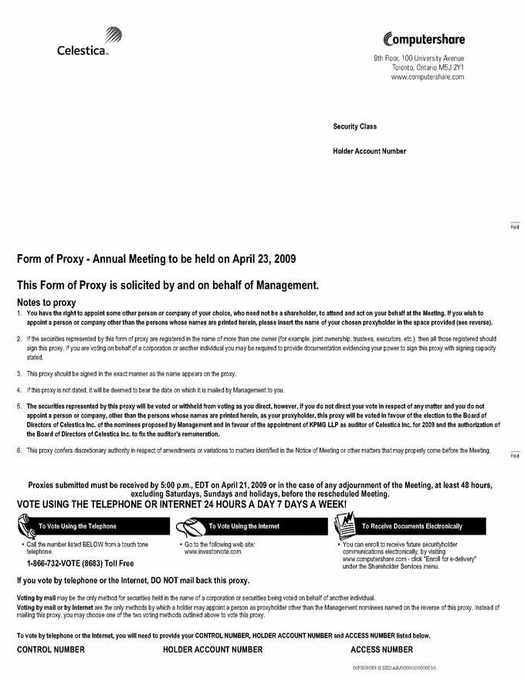

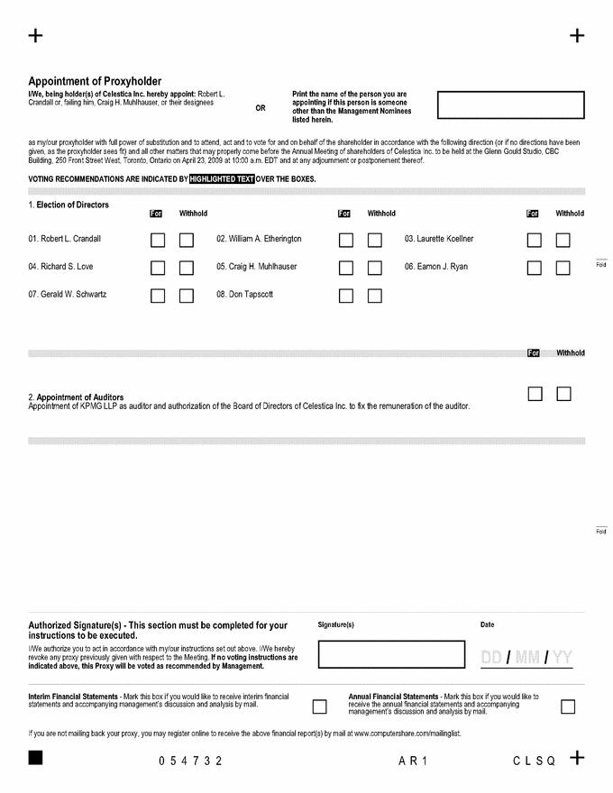

Exhibit 99.3
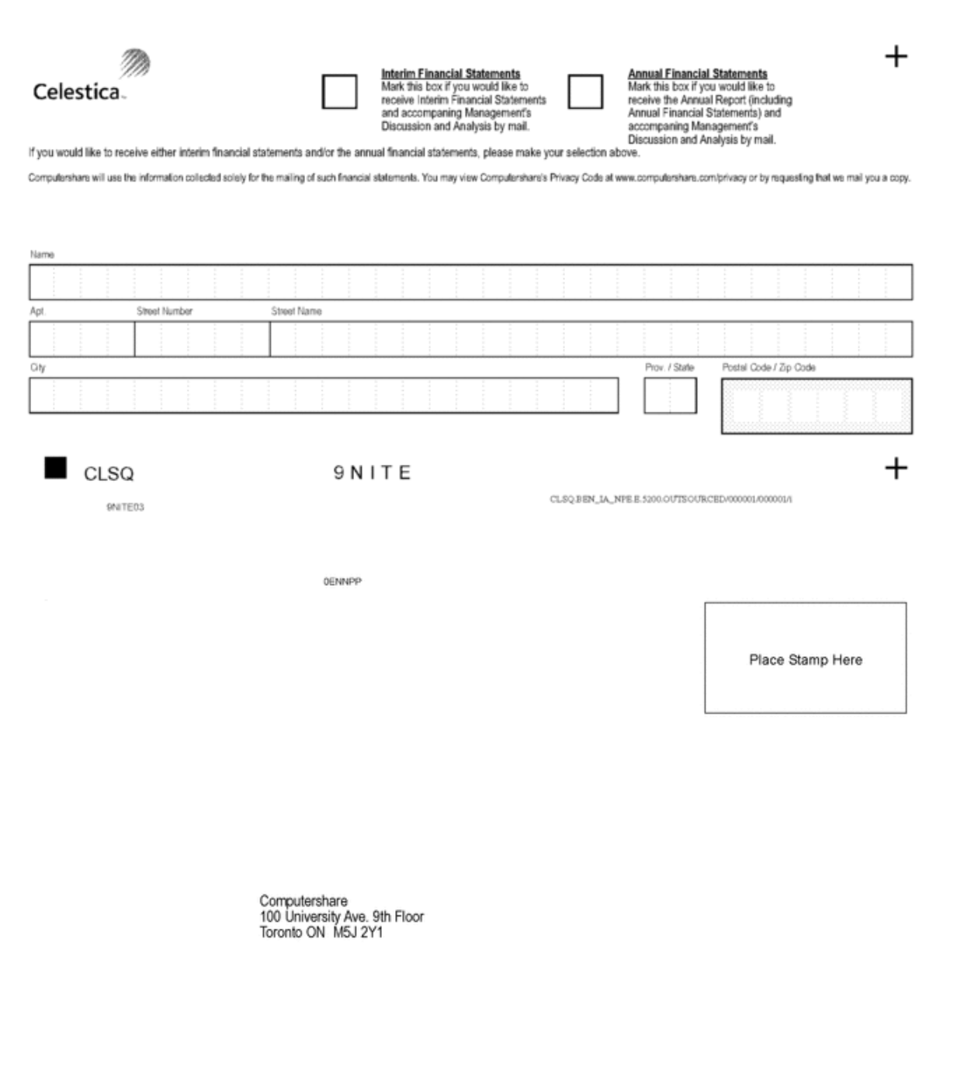

Exhibit 99.4



Celestica Inc.

Annual Meeting of Shareholders

April 23, 2009 at 10:00 a.m. (Eastern Daylight Time)

Glenn Gould Studio

CBC Building

250 Front Street West

Toronto, Ontario

Proxy Login Details:

Control Number: [[ControlNumber]]

Holder Account Number: [[HolderAccountNumber]]

Proxy Access Number: [[ProxyAccessNumber]]

To: [[Registration]]

As a holder, you are entitled to receive the Proxy, Notice of Meeting and Management Information Circular for the Annual Meeting of Shareholders, Form 20-F for the fiscal year ended December 31, 2008, and the Chief Executive Officer’s Letter to Shareholders. You are also entitled to vote your shares for the Company’s Annual Meeting.

To cast your vote, please visit www.investorvote.com and follow the on-screen instructions. You will be prompted to enter the proxy voting details provided above in this email to access this voting site. Proxies submitted by the Internet must be received not later than 5:00 p.m. Eastern Daylight Time on Tuesday, April 21, 2009.

To view the Proxy, Notice of Meeting and Management Information Circular for the Annual Meeting of Shareholders, Form 20-F for the fiscal year ended December 31, 2008, and the Chief Executive Officer’s Letter to Shareholders, visit:

www.celestica.com/InvestorRelations/InvestorRelations.aspx?id=1666

Thank you for using our online voting service.

Please note: You are receiving this email because you are signed up for Electronic Shareholder Communications, our environmentally friendly eComms service. You can unsubscribe to email notifications at any time by changing your elections on the Electronic Shareholder Communications menu at Investor Centre.

Questions? For additional assistance regarding your account please visit www.computershare.com/service where you will find useful FAQs, phone numbers and our secure online contact form.

Exhibit 99.5


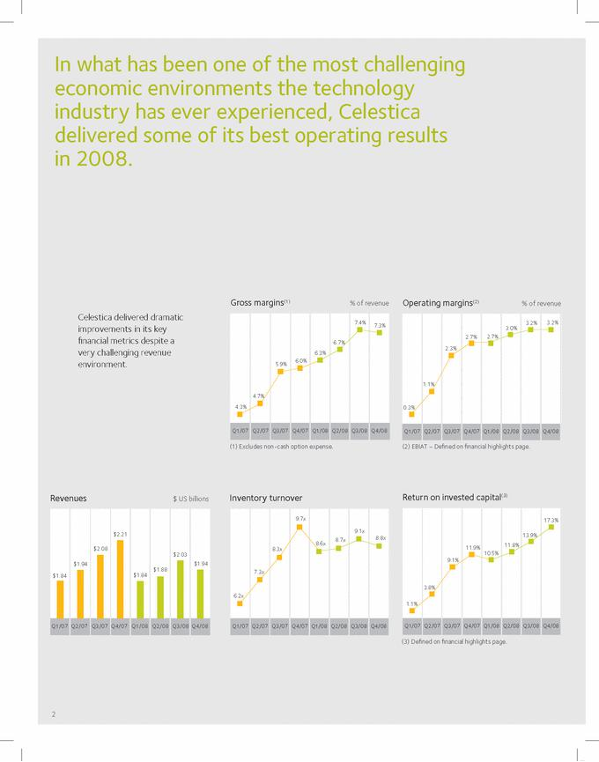

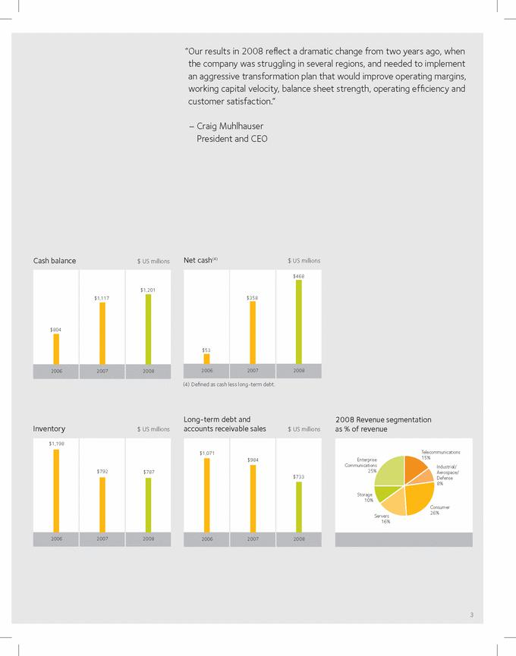

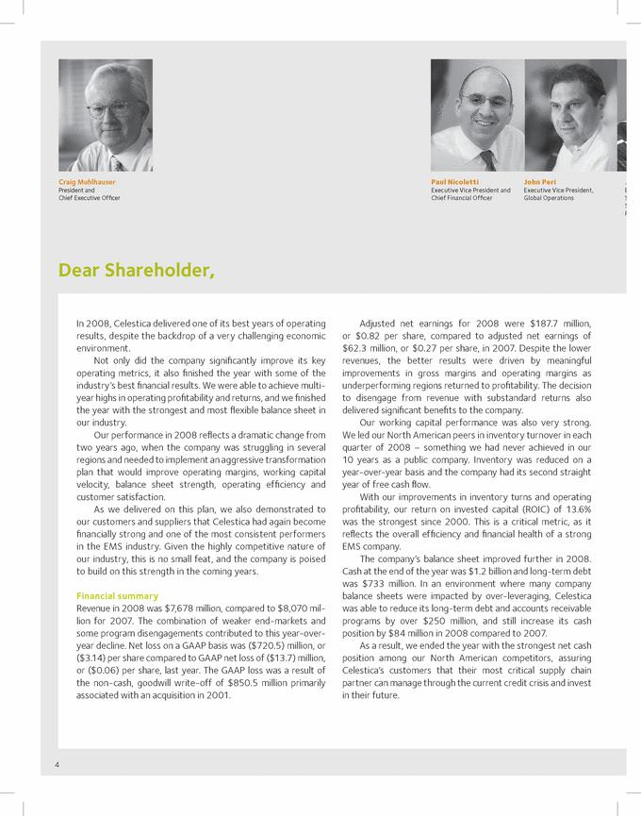

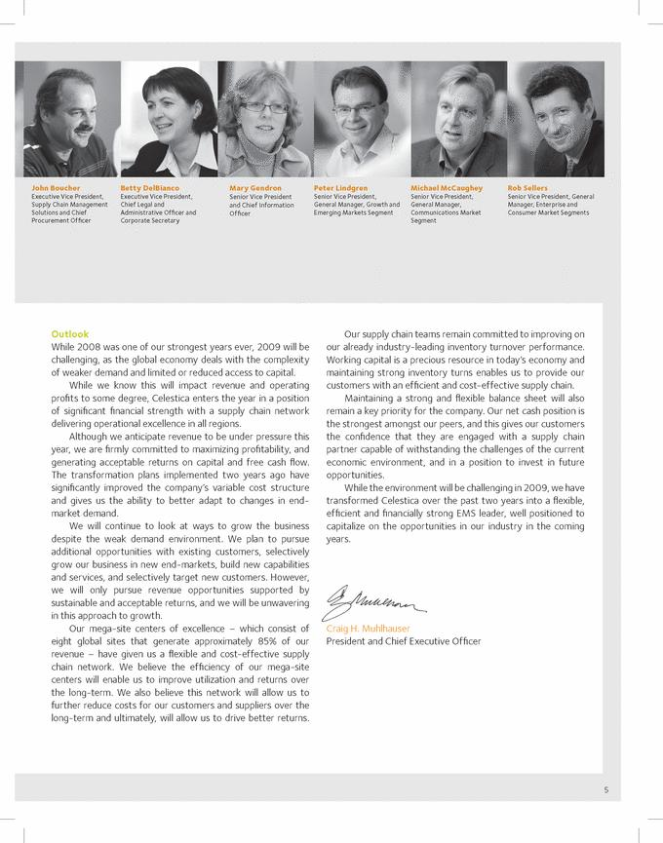

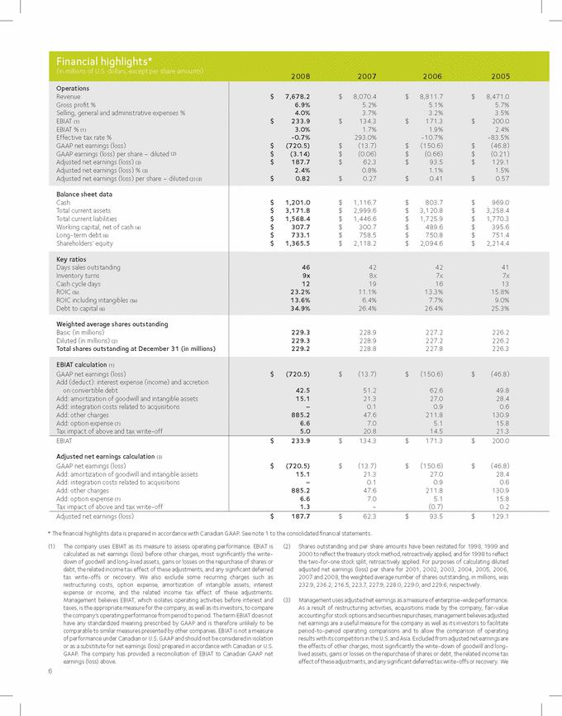

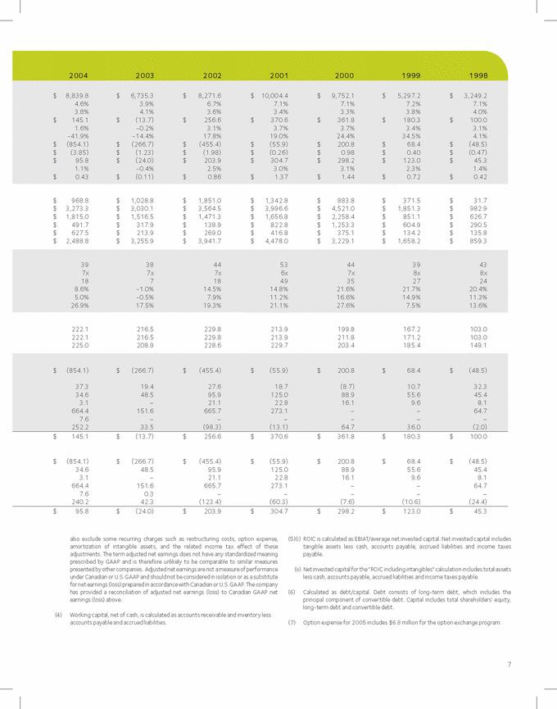

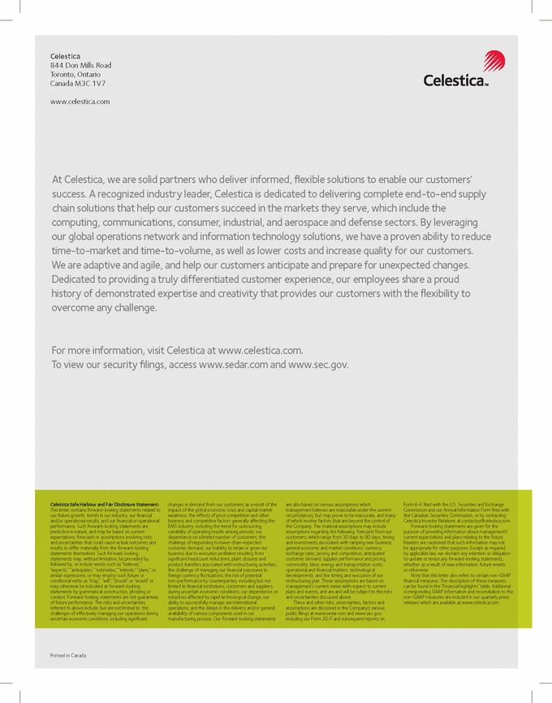

Exhibit 99.6

FOR IMMEDIATE RELEASE Tuesday, March 24, 2009

CELESTICA FILES FORM 20-F

TORONTO, Ontario - Celestica Inc. (NYSE, TSX: CLS), a global leader in the delivery of end-to-end product lifecycle solutions, today announced that its annual report on form 20-F for the year ended December 31, 2008 has been filed with the United States Securities and Exchange Commission.

The annual report on form 20-F can be accessed on the company’s website at www.celestica.com. The form 20-F can also be viewed at http://www.sedar.com and the Edgar Filing on http://www.sec.gov.com.

The company’s shareholders are entitled to receive copies of the Form 20-F free of charge. Shareholders can request the document on the Investor Relations page of Celestica’s website at www.celestica.com. Shareholders who have already requested copies of Form-20F will receive these documents in the mail.

About Celestica

Celestica is dedicated to delivering end-to-end product lifecycle solutions to drive our customers’ success. Through our simplified global operations network and information technology platform, we are solid partners who deliver informed, flexible solutions that enable our customers to succeed in the markets they serve. Committed to providing a truly differentiated customer experience, our agile and adaptive employees share a proud history of demonstrated expertise and creativity that provides our customers with the ability to overcome any challenge.

For further information on Celestica, visit its website at http://www.celestica.com.

The company’s security filings can also be accessed at http://www.sedar.com and http://www.sec.gov.

 |  |  | - 30 -
For further information, contact:
 | Laurie Flanagan |  | Paul Carpino
 | Communications |  | Investor Relations
(416) 448-2200 |  |  | (416) 448-2211
 | media@celestica.com |  | clsir@celestica.com

